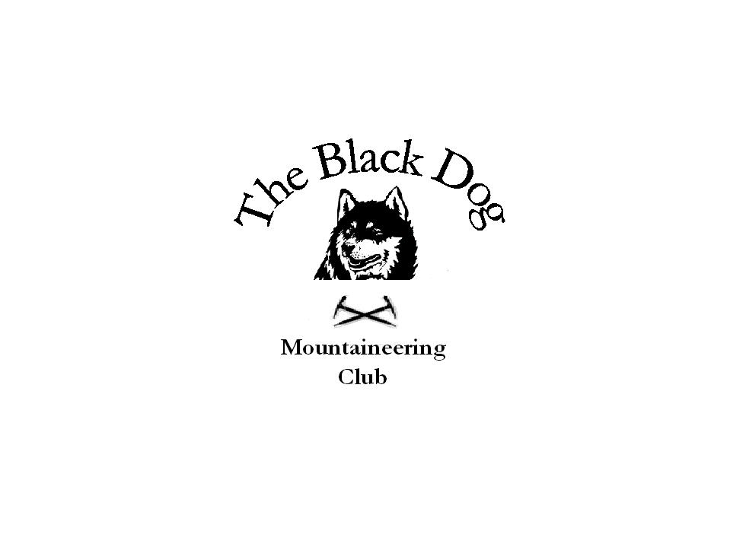Black Dog Meet

No. 2 (Aultguish Inn 22nd – 26th March)

Date Sat 23rd March, 2002.

Hill/s Climbed An Teallach Traverse
(Bidean a Ghlas Thuill 1062m, Sgurr Fiona 1060m and 5 tops)

In Attendance Charlie Alexander
Chris Barbour
Dave Barbour
Mike McLaggan
Alan Sewell
Ross Watson

Weather Clear sunny day, mild on the tops very little wind.

Snow Conditions Deep and soft in places but the rock was dry.

Notes Decision made to take three cars, drop one off at the east end
of the hill which would allow us to complete the traverse
without walking back along the main road to the starting
point. The Chairman dropped his car off and we set off in the
other two cars to the West end of the hill. However after about
an hour up the hill the Chairman discovered he had left his car
keys in the glovebox one of the cars below. (Say no more
about that one). Luckily at the end of the day the two best
looking guys shot off down the track to cadge a lift along the
road.

Notes Ctnd. Great views and some interesting route finding our way across
the ridge.

Some of Dave Barbours comments were classic i.e. “alang
there ! yer fu**in jokin me”

All in all a great day, which is a feather in the cap of most folk.

10 hours on the hill starting at 9am finishing at 7pm.

Quiet night in the hotel early bed for us all.

Date Sun 24rd March 2002.

Hill/s Climbed Sgurr Breac 999m and A’Chailleach 997m
(Dave, Chris, Ross, Charlie and Mike).

Meall Doire Faid 730m and Beinn Enaiglair 890m (Alan
Sewell).

Ben Wyvis 1046m (Dave Binnie and Dave Hadfield).

In Attendance Dave Barbour

Chris Barbour
Charlie Alexander
Mike McLaggan
Ross Watson

Alan Sewell (Beinn Enaiglair and Meall Doire Faid).

Dave Binnie (Ben Wyvis)
Dave Hadfield (Ben Wyvis)

Weather Alan had a nice dry sunny day and was back at his car at
2pm.

The two Dave’s had a dry day on Ben Wyvis.

The rest of us spent the day in wind and rain, 6.5 hrs on the
hill.

Snow Conditions None on any of the hill’s to speak of, only on the faces.

Notes The two Dave’s drove up from Edinburgh in Dave Binnie’s
heap.

Charlie took a bit of a tumble but was unscathed (think he
meant it).

Good night in the hotel three guitars, and not a singer among
us !!

Date Mon 25th March 2002

Hill/s Climbed Moruisg 928m and Sgurr nan Ceannaichean 915m

In Attendance AlanSewell
Dave Binnie
Dave Hadfield

Weather Clear but with showers

Snow Conditions Nil – only patchy

Notes Steep pull up Moruisg from the road. Misty with slight drizzle. From Moruisg to Sgurr nan Ceannaichean sunny – nice ridge round – very cold wind.
Steep descent off. Sat and sun bathed by the stream in the coire. Then came the rain again.

Date Tues 26th March 2002-03-28

Hill/s Climbed Beinn Liath Mhor a Ghuibhais Li 766m

In Attendance AlanSewell
Dave Binnie
Dave Hadfield

Weather Excellent – good views all round – Fannich’s , An Teallach to the Cairngorm’s.

Snow Conditions Nil

Notes This hill is a very good view point for it’s size. Well worth the minimal effort (1hr 20 min to the top).
Went swag hunting in Aviemore…on returning I found that I had a flat tyre – prayed all the way back that I didn’t get another one on the baldy spare that I put on.

