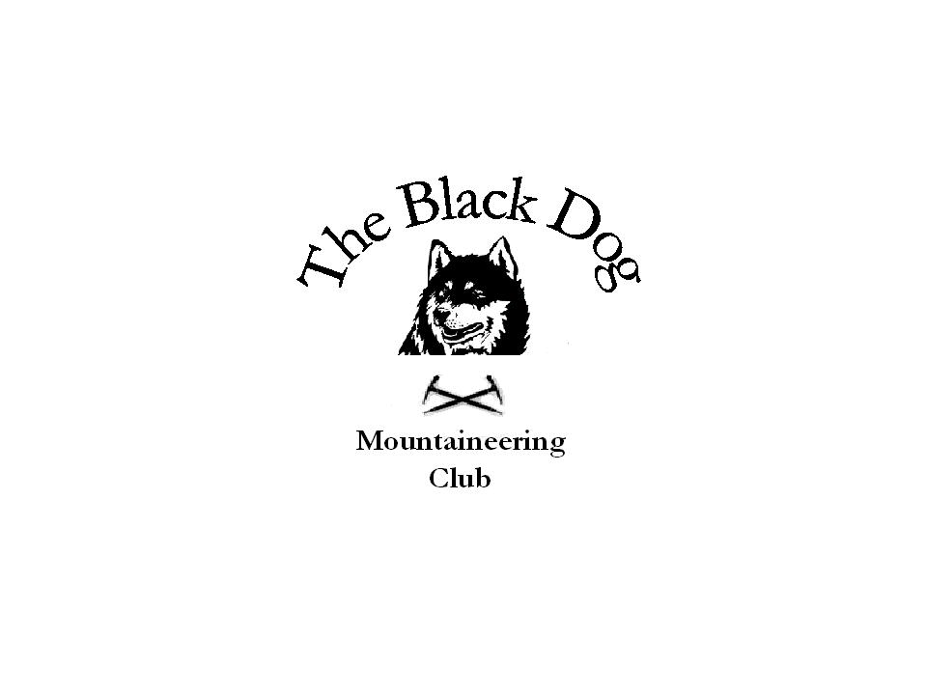Black Dog Meet

No. 17

Date -Sat 30th Aug 2003 (Glencoe Meet)

Hill/s Climbed –
Buachaille Etive More - Fiona, Andy R, Dave , Chris, Andy S, Gerry, Ken, Tony, Alan
Stob Coire Sgreamhach- Steve S

In Attendance Fiona O'Neil
Ken Rae
Andy Robb
Gerry Feeney
Steve Smart
Tony Smith
Alan Sewell
Chris Barbour
Dave Barbour
Andy Scott

Weather Conditions good - warm, sunshine all day, cloud level above 4000ft

Snow Conditions N/A

Notes Left Montrose at 6.30am. Breakfast stop at the Green Welly shop (good breakfast) in Tyndrum at around 9.00am. Met up with Andy S who had driven up from Glasgow. All but Steve S decided to do the Buachaille opting for Stob Coire Sgreamhach instead.
A group of 7 (Fiona, Ken, Andy R, Andy S, Gerry, Dave and Chris) headed up Coire na Tulaich and up on to Stob Dearg. Then continuing along the ridge to do the tops of Stob na Droige, Stob Coire Altruim and the other Munro Stob na Broige followed by a return back down the glen.
Steve S headed up the lost valley and up on to Sgreamhach and back over the tops of the Beinn Fhada ridge decending NE at the end.
Tony and Alan headed to the North of the Buachaille and roped up for Crowberry ridge. An interesting route starting from the bed of crowberry gully, up a chimney and then a traverse out on the left-hand wall which leads on to crowberry ridge itself. The exposure was sensational and highly recommended. The route finishes with a scramble up the ridge over Crowberry tower to the summit. The top of Stob na Droige was then taken in followed by a descent of Coire na Tulaich.
All returned to the car park at Lagangarbh by about 4.00pm and made a hasty retreat from the midges to the Kings House hotel for a swift pint.

A good day had by all.

Mike McLaggan Club Secretary
pp Alan Sewell

Note:

Next meet is a weekend meet (27th/28th Sept) to Aviemore. All interested to contact Mike McLaggan ASAP.

All interested in attending the Xmas meet (13th Dec) in Glen Clova should contact Gerry Feeney who is organising Xmas Lunch in the Clova Hotel afterwards.

