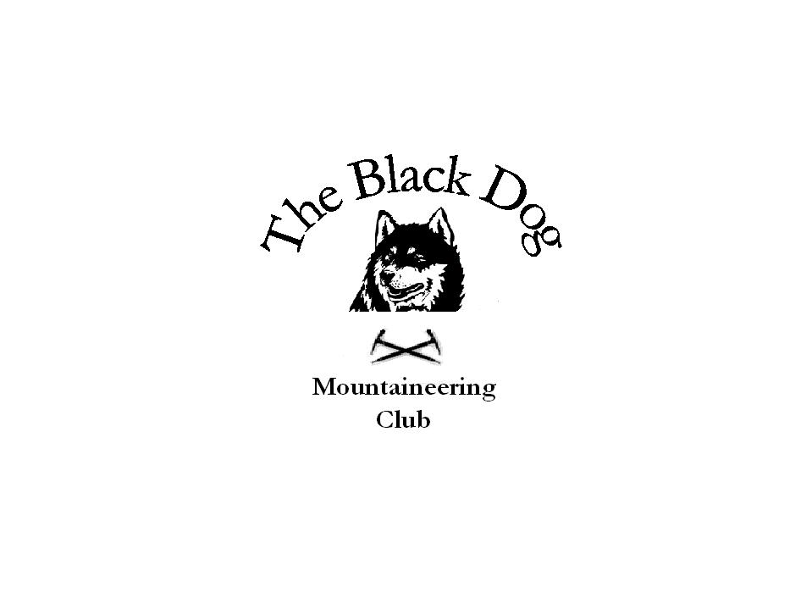Black Dog Meet

No. 27a “Glen Nevis”

Date Saturday 31st July 2004.

Hills Climbed Beinn an Gainimh 730m
Newtyle Hill 317m

In Attendance Steve Davis
Jenny Davis
Tony Smith

Weather Overcast and very humid. Some sun later.

Notes I think we knew that planning a long day-trip in the middle of the local holiday was probably not the best idea, but that was what we agreed at the meeting last October. In the event only three of us confirmed interest and we elected to go visiting ‘relatives’ again, rather that spend 6 hours travelling to Nevis.

For the record Beinn an Gainimh stands above Glen Almond between Crieff and Loch Tay and we set out from the Glen Quaich road 3 miles from Amulree (ignoring the stalking notice, which looked as if it had been there for about 5 years, and deciding the “No Bikes”, “No Fishing” and “No Fires” signs were irrelevant). This was a straightforward walk of about 3 hours (although the North side of the hill is steep and very rough in places).

We stopped at the Loch of Lowes reserve on the way home to “just pop up” Newtyle Hill. For any considering the same trip my advice is simple - “Don’t”! The view from the top was good enough but getting there was something else. It’s only a mile from the road and there’s a good waymarked track initially but the heather and bracken thereafter was purgatorial (not helped by the high humidity and very persistent flies). In the terms of the Marilyner’s newsletter a true “Wee Shite”!

Regards,
Tony Smith

