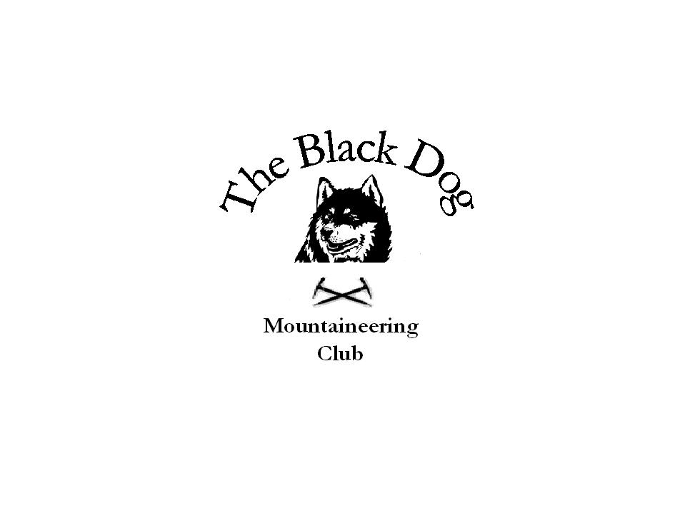Black Dog Meet

No. 30 Torridon Area

Date - Fri 29th to Sunday 31st October 2004.

Hills Climbed Friday Sgurr na Feartaig (2828), Creag Bheag (1597)

Saturday Sgurr Mor (3642), Beinn Liath Mor Fannich (3130), Meall Gorm (3114), An Coileachan (3028), Sgurr nan Lochan Uaine (2864), Sgurr Dubh (2566),

Sunday Moruisg (3045), Sgurr nan Ceannaichean (3002
Bac an Eich (2671)

In Attendance Alan Sewell
Tony Smith
Lorna Smith
Sally Varian (Guest)
Steve Davis
Mike McLaggan
Gerry Feeney
John Stewart

Weather Fri - Very wet am, dry pm, cloudy
Sat - Frost am, clear blue skies, some low mist, no wind.
Sun - Cloud, windy on top

Snow Conditions None

Notes Friday

Steve and Alan left Montrose at 8.00am and headed to Glen Carron to do Sgurr na Feataig. Weather was horrendous driving north until Drumochter where the rain eventually went off. The hill took around two hours to the summit due to the good stalkers path all the way.

John left Montrose around 8.00ish only to find that the cash point in Coupar Angus wouldn't give him any money - as his card had expired. After being refused cash back in the co-op he decided to return home. Eventually arriving at Aultguish around 5.00pm.

Tony, Lorna left Montrose and picked Sally up at Dunkeld around 2.00pm. A quick dash up Creag Bheag (Kingussie) and arrived at Aultguish at around 7.00pm.

Gerry and Mike left Montrose after work to arrive at the hotel around 8.30pm.

Saturday

The weather had improved on the Saturday and the morning was cold with frost and clear blue skies.

Tony, Lorna, Sally, Gerry and John headed off to do 4 Munros in the Fanniches from the Loch Droma side. The going was tough across to the most southern Munro - An Coileachan but came out of the mist to be rewarded with a temperature inversion. Having left at around 9.15am a 9 hr day unfolded arriving back at the hotel in the dark at around 7.00pm.

Mike, Alan and Steve did a couple of Corbetts in Torridon giving fantastic views across to Liathach, Beinn Eighe and Skye. Setting of at 9.30am and arriving back in the glen at 3.00pm. The going was rough between the two and we all agreed it would be a navigational nightmare in bad weather (you've been warned).

Sunday

We had all hoped for a similar day on Sunday but it wasn't to be. A fresh wind with low cloud greeted us in the morning.

Steve, Alan, Lorna, Tony and Sally headed for Strathconon. A beautiful glen reminiscent of Glen Lyon. Another Corbett - Bac an Eich was climbed with a strong wind and cloud just catching the summit.

Mike, Gerry and John headed for Glen Carron and climbed Sgurr nan Ceannaichean and Moruisg. Similar condition with strong wind and cloud were encountered.

All arrived safely back in Montrose around 5-6pm.

Extra Notes

Although the climbing over the weekend had been excellent I thought it would be useful to highlight some other issues over the weekend - namely the accommodation.
The club has used the Aultguish hotel before under previous owners and although fairly basic does provide cheap and cheerful accommodation in a good location.

However this weekend was different. As a summary I can only say "we was robbed".

I will list some of the issues to give you a taste of what went on.

Original quote for room £20 a night B&B. This then changed when it came to pay the bill to £29.50 without warning.

Price £29.50 per person per night for a room containing four people. Total room charge approx £120 a night - extortion.

Room was cold with no hot water!! Nothing like a cold bath when you come off the hill is there.

Breakfast - cold porridge, half cooked breakfast. A choice of white coffee (only one cup per person though).

Meals at night though good were I would say over priced. (approx £10 quid for haggis neeps and tatties).

No dialogue from new owners with the guests - not at all interested in whether you were having a pleasant stay or not.

Another club at the hotel had a similar experience where they were charged for a room and a meal for someone who wasn't there.

I can only recommend that the club does not use this place in the future and that we spread the word to others.

This was disappointing for the last weekend meet of the year after so many good trips earlier in the year.

A reminder that the next day meet is to Inverlochlarig (south of Stobinnian) at the head of Loch Voil. Contact meet organiser Mike McLaggan if you are interested in coming along.

Also a final reminder about the Xmas meet. The meet is to Braemar followed by a meal at Roos leap (Montrose) in the evening. Contact Gerry Feeney if you wish to go along to either.

Regards - Alan

