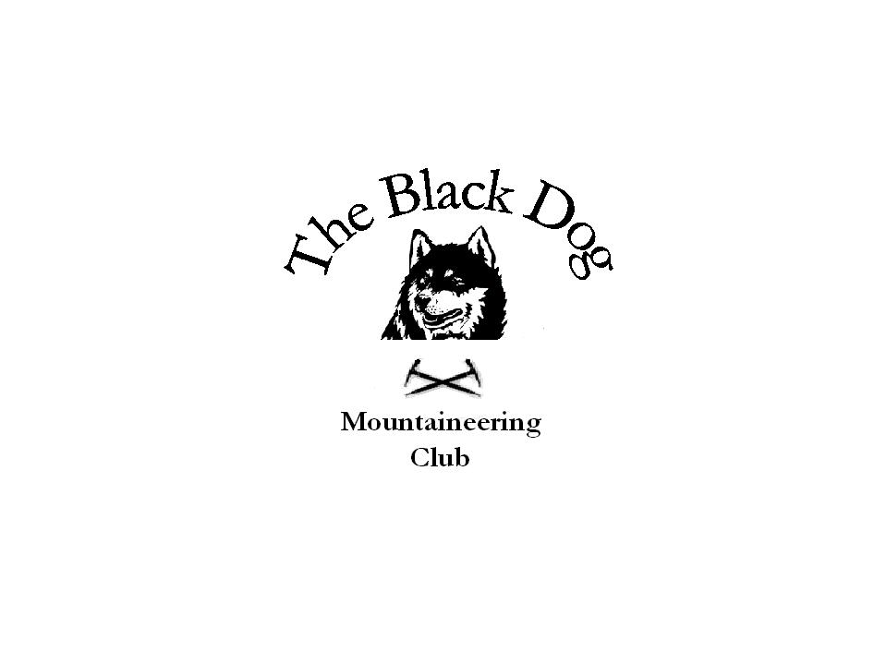Black Dog Meet

No. 31 Inverlochlarig

Date - Sat 27th Nov 2004.

Hills Climbed Ben Chonzie (931m) Mike,Steve S,Fiona,Dave,Chris,Andy,Jo Creag Uchdag (879m) Alan
Shee of Ardtalnaig (759m) Tony,Charlie

In Attendance Alan Sewell
Dave Barbour
Chris Barbour
Jo Barbour
Tony Smith
Steve Smart
Andy Robb
Mike McLaggan
Fiona O’Neill
Charles Alexander

Weather Cloudy dull and overcast at first followed by snow higher up then rain.

Snow Conditions Dusting higher up

Notes
Forecast dictated a change of venue so we opted to stay a bit
further east .
We met in Crieff at 0830 for a breakfast stop (outside on the
street)
Day started off ok with no rain but by the time we were heading
back to the cars the heavens had opened.
Stopped off in Comrie for a pint on the way home.

Welcome to Jo Barbour, our latest recruit.

Next meet will be in Braemar on the 11th Dec followed by a
Roos leap.

Mike McLaggan 29-11-04

