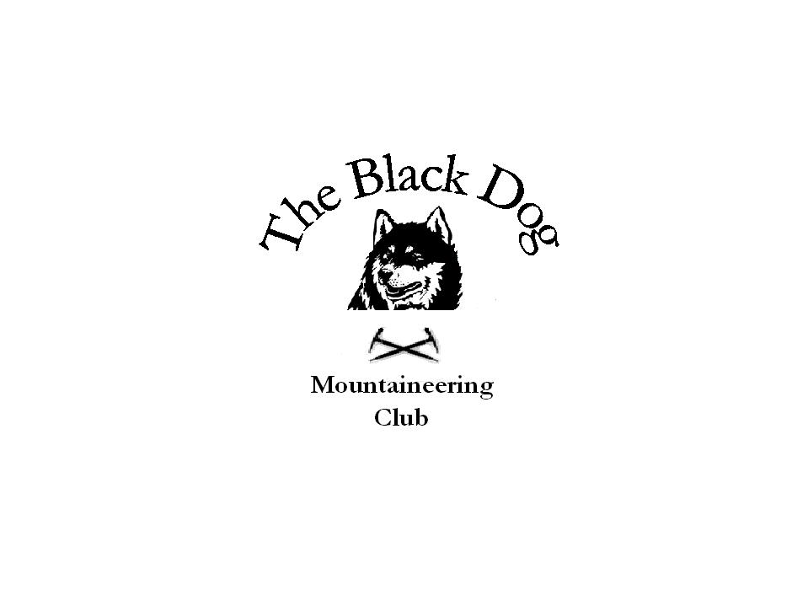Black Dog Meet

No. 35 – “Aviemore”

Date - Saturday 19th March 2005.

Hills Climbed Carn Dearg (945m),
A’Chailleach (930m),
Carn Sgulain (920m),
Creag Laith (743m)

In Attendance Steve Smart
Fiona O'Neil,
Andy Robb,
Ken Rae

Dave Barbour and myself should also have been in attendance but we had to call off because of illness.

Notes After meeting up at Dalwhinnie for Bacon Rolls it was decided to head for the Monadh Laith instead of the Cairngorms. Steve and Fiona climbed all four hills with Andy and Ken taking the Landrover track back to the start after completing the three Munros. Most of the snow, which has been seen on the hills over the last few weeks, had disappeared leaving only patches, which were soft on top but hard underneath. Weather was fine, cloud on the tops at the start but above summits during the afternoon.

Next meet is on Sunday 24th April in Glen Lochay; hopefully we will get a better turnout then.

Gerry Feeney

