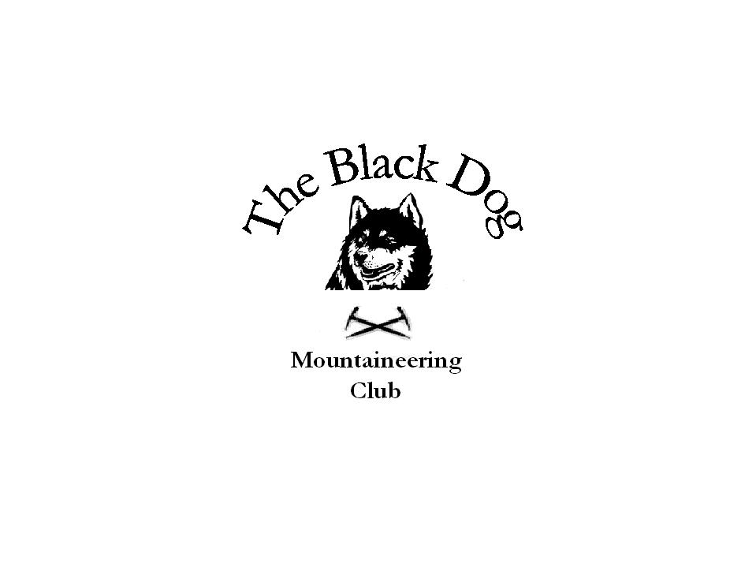Black Dog Meet

No. 36 - Crianlarich

Date - Thurs 7th Apr 2005.

Hills Climbed

Ceann na Baintighearna (771M) Steve D & Tony
Creag Mhor (685M) Steve D & Tony

Ben Oss (1029M) Steve S, Fiona, Ken & Dave
Beinn Dubhchraig (978M) Steve S, Fiona, Ken & Dave

In Attendance Dave Barbour
Steve Davis
Fiona O’Neil
Ken Rae
Steve Smart
Tony Smith

Weather Very windy conditions with snow showers.

Snow Conditions Snow down to 300m - soft snow conditions.

Notes Set off at 07:00 hrs stopping off at Crieff for Bacon Butties.
Split into our two groups from here and headed on our way.
One member who will remain anonymous but had previously forgotten his boots was phoned on route to let him know that his jacket was still on the back of the kitchen chair. As usual a spare was at hand. I think a checklist will be required in the future.
Lasso required on top to keep Fiona from being blown away by the gale force winds.
The Munro baggers had the usual soup and a pint before going home.

Dave Barbour 22-Apr -05

Next meet Glen Lochay 24th April - Contact Steve Smart.

