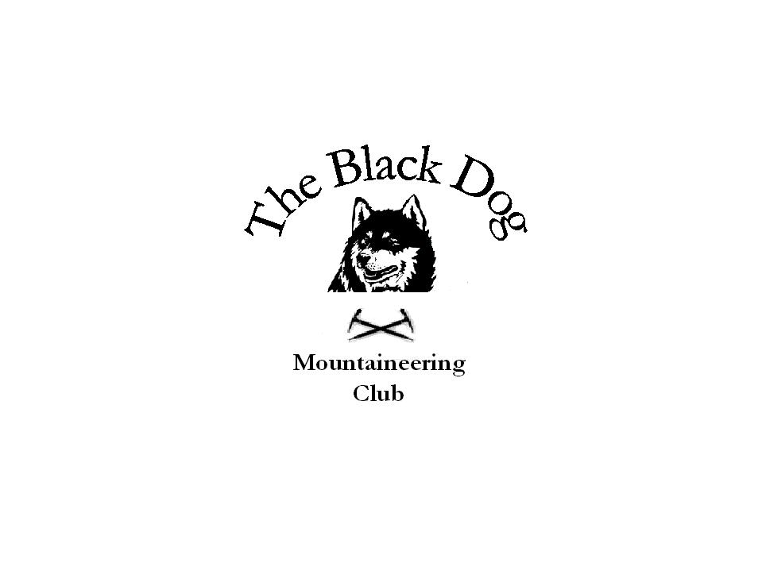

Black Dog Meet.
N0. 37 Glen Lochay.

Date-Sun 24th April 2005.

Hills Climbed Meall Ghaordaidh [1039m] Charles,Gerry,Andy,Tony.
Meall Glas [960m] Dave,Fiona,Ken,Steve.
Sgiath Chuil [935m] Dave,Fiona,Ken,Steve.
Beinn nan Oighreag [909m] Charles,Gerry, Andy,Tony
Beinn nan Imirean [849m] Fiona, Steve.
Beinn Dearg [830m] Alan.
Meall nan Subh [806m] Alan.
Meall nam Maigheach [779m] Alan.

In Attendance Charles Alexander.
. Dave Barbour.
Gerry Feeney.
Fiona O’Neil.
Ken Rae.
Andy Robb.
Allan Sewell.
Steve Smart.
Tony Smith.
.

Weather Started off cloudy but soon this burnt away to leave fine blue skies
although there was a chilly breeze on the ridges.

Snow Conditions Just the odd patch on the lower Munros and Corbetts, but the higher
Munros still had some significant banks and cornices.

Notes After a breakfast stop at Ballinluig with old firm fans and brownies
we escaped to the peace of the mountains.
Four set off from Duncroisk in Glen Lochay for a Munro & Corbett
double. Alan started on the Lawers to Lyon road for a Corbett treble
using the car in between.
The remaining four parked at Kenknock in Glen Lochay. Fiona and
Steve did the Corbett first before finding Dave and Ken sunning themselves
on Sgiath Chuil. There seems to be a bit of a mystery, Dave started the day
with two maps butt finished with one. Maybe we’ll get to the bottom of this
one day, only Dave knows.

Next meet is Skye 21st may.

Steve Smart 25-04-05.

