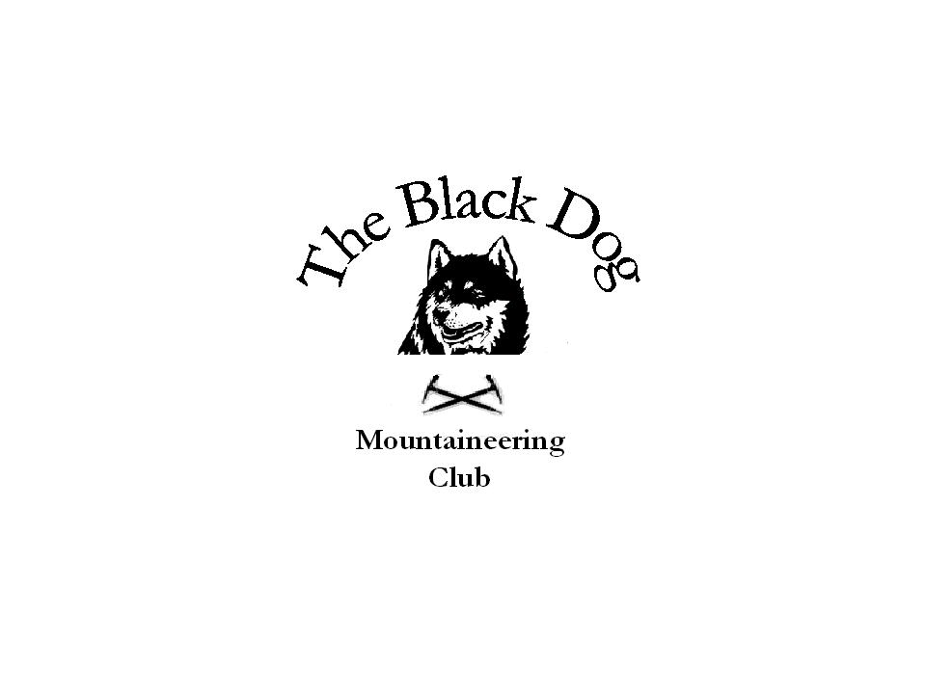Black Dog Meet

No. 38 - SKYE

Date - 20th-22nd May 2005.

In Attendance Dave Barbour
Dave Binnie
Andy Scott
Colin Sidgwick
Alan Sewell
Steve Smart
Lindsay Wyllie
Sandra Wyllie
John Stewart
Kevin Prudhoe
Brandy

Hills Climbed

Friday

Bruach na Frithe - Alan, Dave Barbour, Dave Binnie, John, Kevin, Steve

Saturday

Sgurr Dearg, Sgurr na Banachdich - Alan, Dave Barbour, Dave Binnie, John, Kevin, Steve, Colin, Andy.

Sgurr Thomaid, Sgurr Ghreadaidh - Steve, Colin

Bruach na Frithe - Lindsay, Sandra and Brandy

Sunday

Am Basteir - Dave Barbour, John, Steve, Colin, and Andy.

Geal Charn - Lindsay and Sandra and Brandy

Weather Friday - Cloud level at about 400m, showers, light winds
Saturday - Cloud level about 400m, showers, hail, moderate wind, brightened up to give the whole ridge clear by 5 pm.
Sunday - Beautiful day, whole ridge clear, blue skies, light winds.

Snow Conditions None.

Notes We set off from Montrose and Inverurie at around 6.00am and all met up as agreed in Glen Brittle around 12.00pm. The plan to do the In Pinn was abandoned due to the weather - Rain and low cloud. The group decided the easiest option would be to do Bruach na Frithe from the top of the Glen Brittle road - which turned out to be a very enjoyable scramble to the summit. A quick nip over Sgurr a Fionn Coire and along to the Basteir tooth for a look at Naismiths route before decending into Fionn Coire and back to the cars.
After a few shandies over a nice meal in the local pub (binge drinking at its best) we all retired to bed with the dulcet tones of a 25min Ian Paice drum solo still ringing in our ears. Colin, Lindsay Sandra and Andy arriving about 10.00pm. The fellowship of 11 was now complete.

After a breezy old night in the bunks where duvets had surely been flapping, the group arose to a reasonable morning. The fog in our heads being thicker than that on the hill, the main group headed for Sgurr Dearg and the Inaccessible Pinnacle. After a 2hr grind up the An Stac screes (the mist being below the lip of Coire Lagan) we arrived at the foreboding west ridge of the Pinn. The water dripped from every hand and foothold of the west ridge and the climb had all the adhesive qualities of a bar of soap. The decision was made as the hail started to bounce on the summit of Sgurr Dearg that the pinnacle would have to wait for another day. The group headed for Sgurr na Banachdich. The ridge gave an entertaining scramble over all the tops, with shifting mist and glimpses of the abyss below, yawning at our heels.
The group split, the fellowship was broken, Steve and Colin headed to Sgurr Thormaid and Sgurr Ghreadaidh and had good fun along the knife edge arete. The day began to improve as the rest moseyed on down in to the coire north of Sgurr nan Gobhar. The sun was out and the demons had been returned to their lairs.
Steve and Colin were picked up on the way up the glen at the youth hostel as we all headed back for an evening of more of the same.
Lindsay, Sandra and Brandy had a very good day on Bruach na Frithe with some views for there efforts.

The Sunday started as the day before, with splitting heads and weary bodies - People all over the world (everybody), Join hands (join), Start a love train, love train………………… Sorry got carried away there.

Dave, Colin, Andy, John and Steve headed for Am Basteir. The weather was fantastic with blue skies, light winds and with the whole ridge stretched out before us. A truly memorable view.
The team managed to avoid the bad step using the scree slopes on the south side of Am Basteir. All made the summit and were back by 4.00pm where Kevin was waiting patiently.

Lindsay, Sandra and Brandy headed for Drummochter to do Geal Charn and on the way had the luck to see a sea eagle above loch Harport. A once in a lifetime moment. Brilliant.

Dave and Alan headed for Struan to pay homage to the great fallen climbers of the past - John McKenzie and Dr Norman Collie - the pioneers of climbing on Skye. The little cemetery at Struan was an idyllic spot where Collie's simple grave had, not surprisingly, a headstone made of Gabbro.
Another great Skye meet - thanks to all those who attended.

We will need to start thinking about booking something for next year.

The next meet is Sat June 11th at Arrochar - names to Tony please.

A Sewell
El Presidente

"We can easily become as much slaves to precaution as we can to fear. Although we can never rivet our fortune so tight as to make it impregnable, we may by our excessive prudence squeeze out of the life that we are guarding so anxiously all the adventurous quality that makes it worth living".

