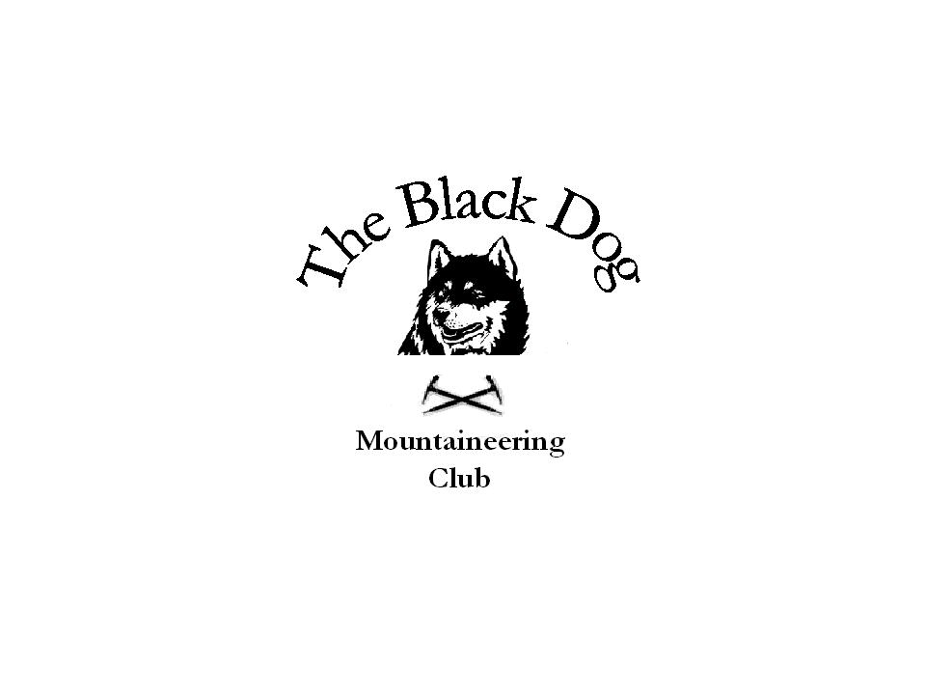Black Dog Meet

No. 39 – “Arrochar”

Date - Saturday 11th June 2005.

Hills Climbed Ben Ime (1011m)
Beinn Narnain (926m)
Ben Vane (915m)
The Cobbler (884m)
Beinn Luibhean (858m)

In Attendance Chris Barbour
Dave Barbour
Fiona O'Neil
Ken Rae
Andy Robb
Russell Shanks
Steve Smart
Tony Smith

Notes A brief (midge infested) meeting in Crianlarich confirmed plans for the day with all agreeing to meet at Succoth (good car parking – busy) and head together to Beinn Narnain. We followed a new path through felled forestry to the weir on the Allt a’ Bhalachain then cut directly up steep grass to join the ridge path to the summit.
Russell and Tony then headed to The Cobbler whilst the others continued to Ben Ime. The Cobbler was very busy in the hot sunny weather but we visited all 3 tops (Main ‘interesting’ and South ‘more so’!) before returning home.
Meanwhile Fiona and Steve went on to Beinn Luibhean and then returned via The Cobbler (it being such a fine day).
Chris, Dave, Ken and Andy traversed to Ben Vane to take their third Munro of the day. Chris was then commissioned to ‘run and fetch the car’ (down the mountain and only 6 miles along the road from Inveruglas) so that Dad could keep an urgent date that evening. He was (quote and not surprisingly) “knackered”.
A good day.

Tony Smith

