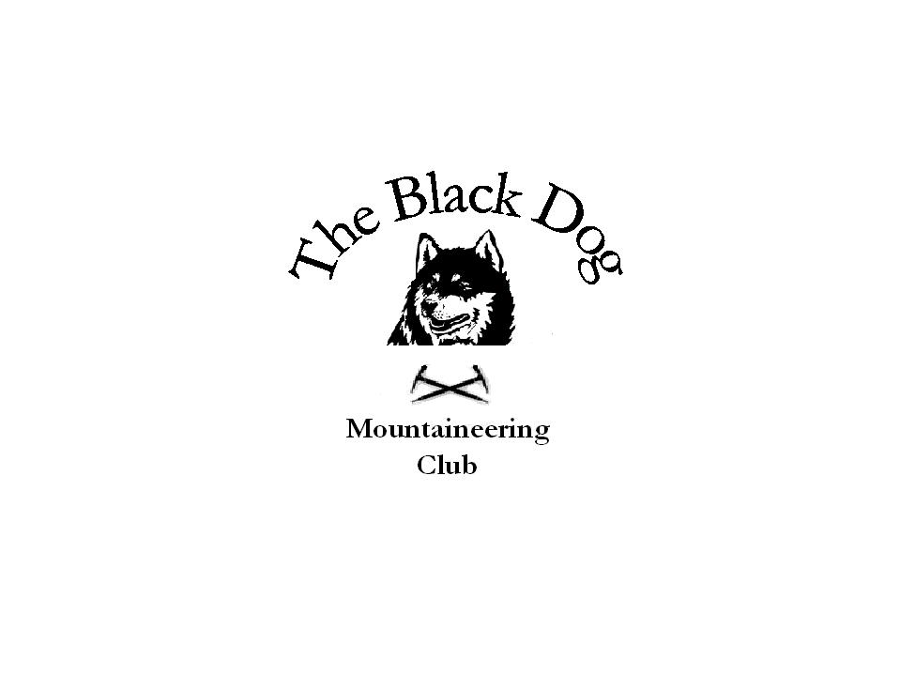Black Dog Meet

No. 40 – “Mull”

Dates - Friday 24th June to Tuesday 28th June 2005.

Hills Climbed Ben More 966m
Beinn a’Chrulaiste 857m
Dun da Ghaoithe 766m
Beinn Talaidh 763m
Sgurr Dearg 741m
Beinn na Duatharach 456m
Beinn na Drise 424m
‘S Airde Beinn 295m
Carn Ban 248m
Gometra 155m

In Attendance Charles Alexander
Jean Alexander
Pat Davis
Jenny Davis
Steve Davis
Gerry Feeney
Alan Sewell
Russell Shanks
Lorna Smith
Tony Smith

Log We all arrived at the Hostel on Mull -Arle Lodge- at similar times on the Friday afternoon. It had been a long “hill less” drive for us all except Alan, who had done a quick up and down on Beinn a’Chrulaiste on Rannoch Moor. Given the excellent weather we decided that an immediate foray into the unknown was in order. A nice easy walk was picked from the local guide book which entailed walking up ‘S Airde Beinn. Surprisingly (!) this hill also turned out to be a Marilyn. A good path from the Mishnish Lochs led to the top, going around the circular ridge, which was the remnant of an old volcano. Great views, but the highlight was the sighting of an adder on the path on the way down. Whilst all of this was going on Jenny chilled out at the hostel, having ruined her heels on ”The Caley Challenge” – a 50 mile sponsored walk - the week before. Dinner was taken at the Fish and Chip Bar on the Tobermory Harbour front – excellent – with a few pints from the local hostelry helping to wash it down.

On Saturday we all went our own way. Russell and Gerry went to Ben More and had a good day going up via A’Chioch and down the tourist route. Whilst the weather was excellent the top remained in mist all day preventing the views which we others got from lower hills. They were very lucky on the road past Loch na Keal, as they were flagged down to see two otters playing in the water. Lorna, Jean, Charles and Tony went up the “deleted” Corbett -Beinn Talaidh, with the mist clearing just at the top. Lorna, Jean and Charles returned to the car, whilst Tony persevered with a walk up Beinn na Duatharach. He completed the traverse getting picked up near Salen, despite having to yomp the latter part in order to keep to his agreed pick up time. Pat, Alan and Steve went up Dun da Ghaoithe, starting from Scallastle Farm. The initial track was boggy but it soon opened out for the trudge to the top. The mist cleared after the second top and during the long descent to the col under Sgurr Dearg. Its NW ridge, with infamous bad step (led by Pat), was a sporting route up before we went down to pick up the second car that had been left there earlier. Dinner was a barbecue – ribs, burgers, sausage, salads, wine and beer. It all went down really well.

Sunday morning dawned as yet another glorious day. Jean, Charles, Tony, Russell and Gerry took in Beinn na Drise as a morning walk, with Alan making an early departure. Gerry, Russell and Jenny left around lunchtime, leaving the remaining six of us to drive down to the SE of the Island for a trip up Carn Ban – one of the smaller peaks on the island. To say that the views were good would an understatement, and sunbathing on the top was the order of the day.

Monday saw Jean and Charles head off home, leaving Lorna, Tony, Pat and Steve to go to Ulva and Gometra. The weather was poorish and it was drizzly for part of the day. Some of us would have been satisfied with the hill on Ulva, but Lorna was not to be denied, and we had to make the long walk out to Gometra. (Editors note: Lorna disputes this version and says it was all down to obsessive, male, Marilyners) It was, however, well worthwhile to see the most unusual “cutting” between the islands and also for the sightings of Hen Harrier, Golden Eagle and Merlin within 5 minutes of each other. The down side was the long walk back. Nevertheless tea and cake at the ferry crossing served to make up for everything.

A great weekend was had by all – I think! Weather was again good for our foray into the Western Isles. The hostel comes well recommended although it was a trifle expensive (£20pppn). However the rooms, showers, cooking, living facilities and the “almost midge free” garden area were very good – you only get what you pay for I suppose.

Steve Davis

