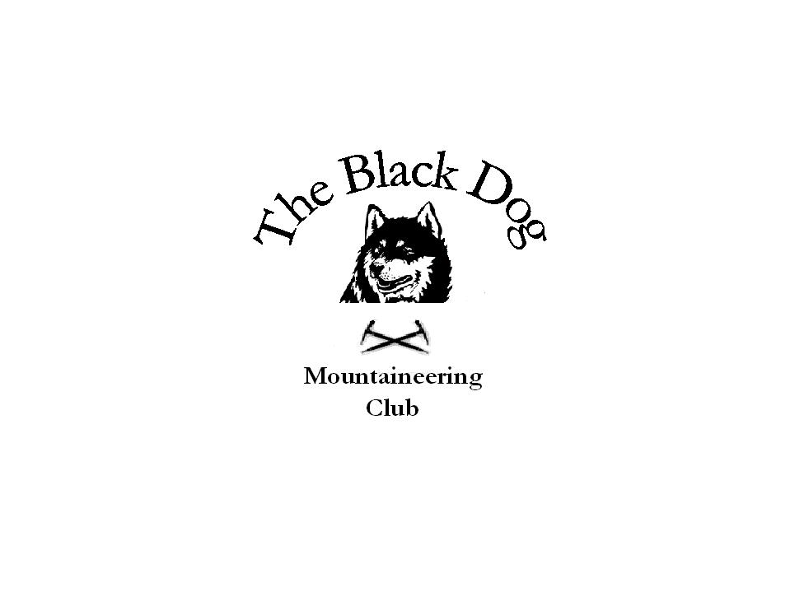Black Dog Meet

No. 44 Lake District

Date - Thursday 13th to Sunday 16th October 2005.

Hills Climbed | Great Gable (899m), Pillar (892m), Kirk Fell (802m), Red Screes (776m), Tinto (711m), Middle Dodd (642m), Binsey (447m), Low Fell (423m), Bishop Forest Hill (392m), Wauk Hill (357m), Long Barrow (352m), Watch Hill (254m), Hightown Hill (250m), See Morris Hill (240m), Muncaster Fell (231m)
In Attendance | Pat Davis, Steve Davis, Jenny Davis, Lorna Smith and Tony Smith
Notes | The first Black Dog foray on English hills, and it’s obviously just coincidence that the majority of the participants are English.  With both Steve and Tony aiming at reaching 600 Marilyns prior to the year-end we took the opportunity to claim some smaller hills on the journey south (including a Smith stop-over in Lockerbie – The Queens Hotel is recommended for food).  As first arrival Steve reported back to those of us still stuck in Carlisle rush-hour traffic that Mike’s much talked about camping barn accommodation was “great”.  Mill House is one of a large number of Lakeland Camping Barns (others were however apparently better equipped) and at £5.50 per night I guess we weren’t expecting much beyond the promised ‘stone tent’. The barn did provide weatherproof sleeping with (on request) mattresses (bring your own sleeping bag), a cooking area (bring your own stove), lighting (but bring your own 50p to boil the kettle) and a WC/wash hand basin (or rather sink) in the yard (bring your own shower). This latter point was, in reality, the only serious downside.  The nearby Gosforth village offered a choice of 3 pubs and the Lion & Lamb provided good beer and food at a very reasonable price. The silver lining!  The other major plus was the weather that was fair throughout although cloud did spoil the views from the higher levels on Saturday.  So what of the actual walking?  Ignoring the relatively minor hills tackled on the way down (although Tinto does offer fantastic views for comparatively little effort – but beware of the cattle!) the Saturday traverse of Pillar to Gable at the head of Wasdale would be good in any context. All three hills are Corbett height and offer great walking. On a fine autumn Saturday all were also exceptionally busy on the main routes. That said I think we were alone on the steep path to Wind Gap (aptly named) before joining the masses on Pillar (not aptly named) plateau. Kirk Crags looked ‘interesting’ from Black Sail pass and this impression was reinforced when we met a descending walker who said that he had failed to reach the summit despite trying two different routes. However ‘Lorna’s Ledge’ provided a suitable alternative to the unattractive gully (despite a touch of Alan’s ‘sewing machine knee’ at one point – quickly forgotten in the bar of The Wasdale Head thereafter).  All in all a very successful weekend with a good tally of new hills and, for me, a somewhat nostalgic return to an old favourite of my Glaxo Ulverston days.  Tony Smith
Next Meet | Trossachs. Saturday 19th November 2005. Mike to organise.

