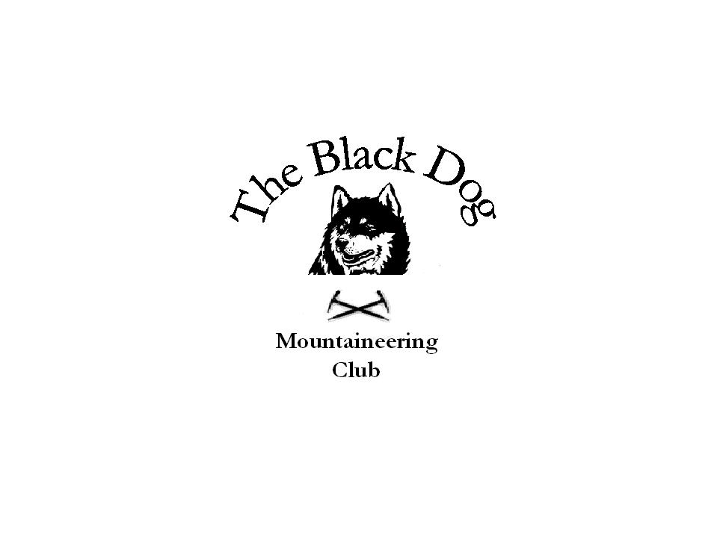Black Dog Meet

No. 45 “Trossachs”

Date - Saturday 19th November 2005.

Hills Climbed | Ben More (1174m), Stob Binnein (1165m), Cruach Ardrain (1046m), Beinn Tulaichean (946m) and Stob a’Choin (869m)
In Attendance | Dave Barbour, Pat Davis, Steve Davis, Gerry Feeney, Fiona O’Neill, Kenny Rae, Andy Robb, Steve Smart and Tony Smith
Notes | Fiona and Steve S made a very early start to do Ben More and Stob Binnein along with some ‘tidying up’ of a previously missed top on Cruach Ardrain from Inverlochlarig. In the event they traversed below the top and did Ben Tulaichean instead. Steve described this as “a brilliant day, pity about the cloud cover”. By the time they returned the Loch Earn to Perth road was blocked by an accident, so it meant a “wee” detour on the way back by Loch Tay. Carrot and red onion soup in the pub is highly recommended.  After a slightly later start Dave, Andy and Ken continued their Munro quest and successfully completed Cruach Ardrain and Tulaichean from the A82 in Glen Falloch.  Pat, Steve D, Gerry and Tony also started (but later still!) from Inverlochlarig and headed West to do Stob a’Choin. A fine hill but like the others we were disappointed with the cloud cover at higher levels, in contrast to the clear frosty conditions in the glens. On return to the car park we greeted another group of walkers whom we had seen leaving earlier in the day. They responded with “more Black Dogs – we spoke to the others from your club on Tulaichean”. Apparently the senior member of their group had, at age 77, just completed his 2001st Munro. Puts my 600 Marilyns into context!  Tony Smith
Next Meet | Christmas. Saturday 10th December 2005. Gerry organising.

