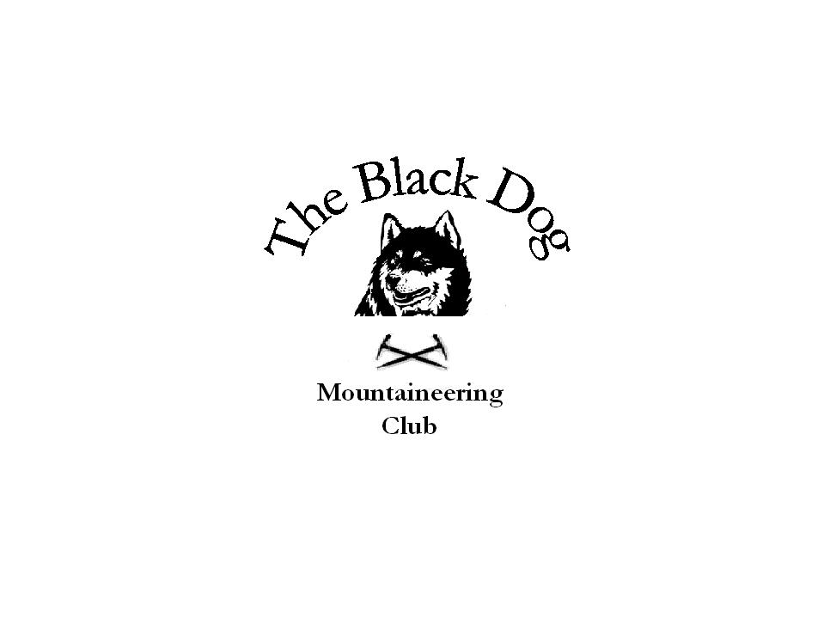Black Dog Meet

No. 46 “Loch Muick”

Date - Saturday 10th December 2005

Hills Climbed | Mount Battock (778m), Creag An Dubh Loch (983m)
In Attendance | Dave Barbour, Gerry Feeney, Fiona O’Neill, Kenny Rae, Andy Robb, Steve Smart
Notes | Fiona and Steve made an early start to head for Loch Muick which they canoe – ed to the west end of to climb Creag an Dubh Loch, a top on Broad Cairn. Wind made the going difficult, even more so on the way back. As a result of this they did not make it to the Northern Vaults until gone half past eight. The walk in involved some wet river crossings and the route to the top was a very wet gully. Mission was accomplished however.  The rest of us had a “lie in” and left Montrose at 08.00.arriving at Millden lodge about 08.30. We set off along the track on the west side of the Burn of Turret which eventually brings you out below Wester Cairn. Followed the ridge along to the summit of Mount Battock where we met a group from a Dundee Hillwalking club which included Neil Boggin, local dentist. We took a shortcut, more by accident than design which brought us back to the track on the east side of the Turret.  On the way up we noticed some marker posts and new bridges over the burn, looks like walkers will be encouraged to use this to bypass the farms at the start of the walk.  Weather was fair but a bit windy on the summit, underfoot conditions were squelchy with most of the snow fallen the pervious week melted.  Part 2  The walkers were joined by Alan Sewell and Chris Barbour for the Christmas meal and drinks at “The Vaults”. The place was lively to say the least but I think we all enjoyed ourselves, meal was OK but not brilliant.  At about 10.00 pm an unlikely looking duo who were the band for the night struck up. That ended all conversation, we retreated to the Golfie when the band announced they would have to turn up the volume because someone in Arbroath complained they couldn’t hear them!  We stayed on at the Golfie until about 1.00 am being entertained by Ken’s card tricks anecdotes and jokes. All in all it was great night out.  Gerry Feeney
Next Meet | “Winter skills” GlenShee 28th / 29th January, contact Mike for details

