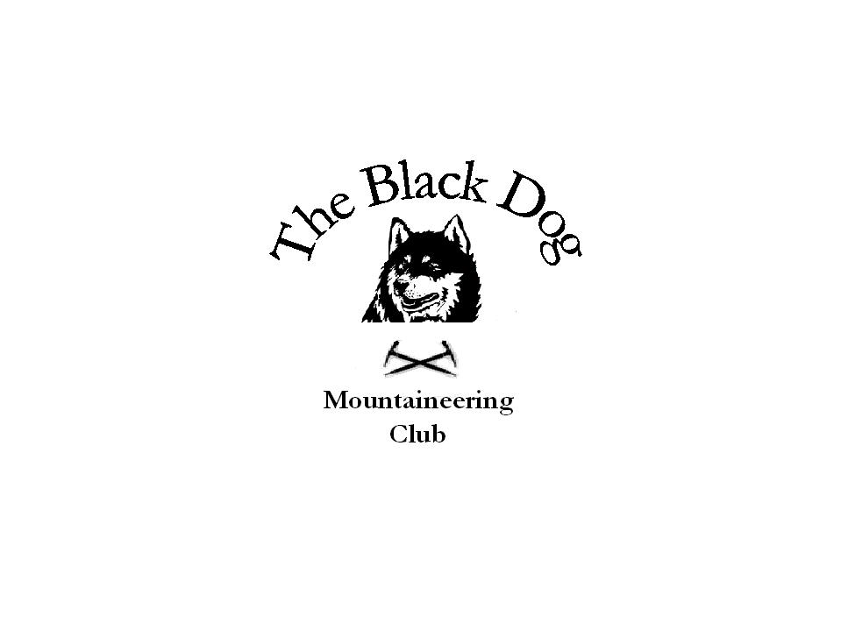Black Dog Meet

No. 47 “Glenshee”

Date - Saturday 28th – Sunday 29th Jan 2006

Hills Climbed | Saturday All (Winter Skills in Coire Fionn on Glas Maol)  Sunday – Mike (MRT Ex on Glas Maol)  Carn an t’Sagairt Mor - Chris , Dave , Charles  Carn an Turic and Cairn of Claise - Tony, Gerry ,Lorna
In Attendance | Dave Barbour, Gerry Feeney, Tony Smith , Lorna Smith ,Alan Sewell , Mike McLaggan , Chris Barbour , Charles Alexander  Saturday only Stewart Richardson and three of his friends from Glasgow and Nick Farrell (Friockheim) for Winter Skills.
Notes | Good accommodation and home cooking at Gulabin Lodge at a reasonable price.  Snow was pretty scarce , but where there was snow i.e. high in Coire Fionn it was hard and perfect for winter skills.  Stuart Richardson’s “perfect” ???? demo of a on the back headfirst ice axe brake was priceless and was worth the journey itself.  Weather especially on the Sunday was superb, started off cloudy but finished off with sunshine and cloud inversion. Superb views from the Cairngorms out towards Ben Lawers.  Would be good to make the winter skills day a regular club outing adding more elements every time ?? Everyone enjoyed the day and took something from the session. Thanks to Alan and Stewart for helping out.  By the way just about forgot how to write these reports !!! it’s been so long !!  Mike McLaggan 30-01-06
Next Meet | Tomintoul meet Sat 25th Feb - Organiser Tony Smith

