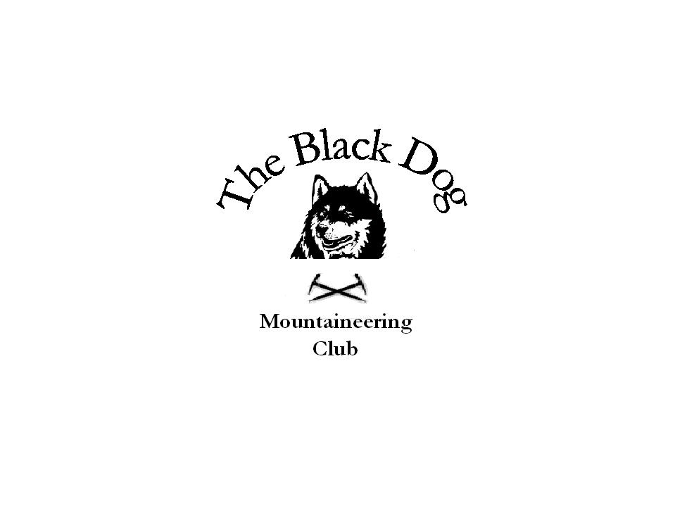Black Dog Meet
No. 48 “Tomintoul”

Date. Saturday 25th February 2006

Hills Climbed. Lochy: Sron a’ Choire Ghairbh (935m) & Meall na Teanga (917m)
Pentlands: Scald Law (579m), Black Hill (501m) & Allermuir Hill (493m)

In Attendance. Gerry Feeney, Fiona O’Neill, Steve Smart & Tony Smith

Notes. Unfortunately a rather poorly attended meet and we decided to ‘do something completely different’. Tomintoul is therefore for another day.

Fiona and Steve went west and did 2 Munros, Meall na Teanga
& Sron a Choire Ghairbh from Laggan Locks. Teanga first then Ghairbh,
descending by the east ridge over Sean Mheall (887m). Teanga had just banks of snow apart from the summit, but Ghairbh had more snow especially the narrow east ridge where it was quite deep. Very strong gusts of wind on the summits, Fiona’s map case got caught in one of them, the last time we saw it was high in the sky heading for Skye, maybe we’ll find it in May.

Gerry and Tony went south and did 3 of the Pentland Marilyns starting from the ranger and visitor centre just west of Penicuik off the A702. This is a well signed and busy area (Edinburgh hill runners and dog walkers) but offers good walking and fine views of the city and Forth estuary. No snow on the ground but also very windy in the sleet showers.

Next Meet. Kinlochewe 25th & 26th March. Dave Barbour organising

