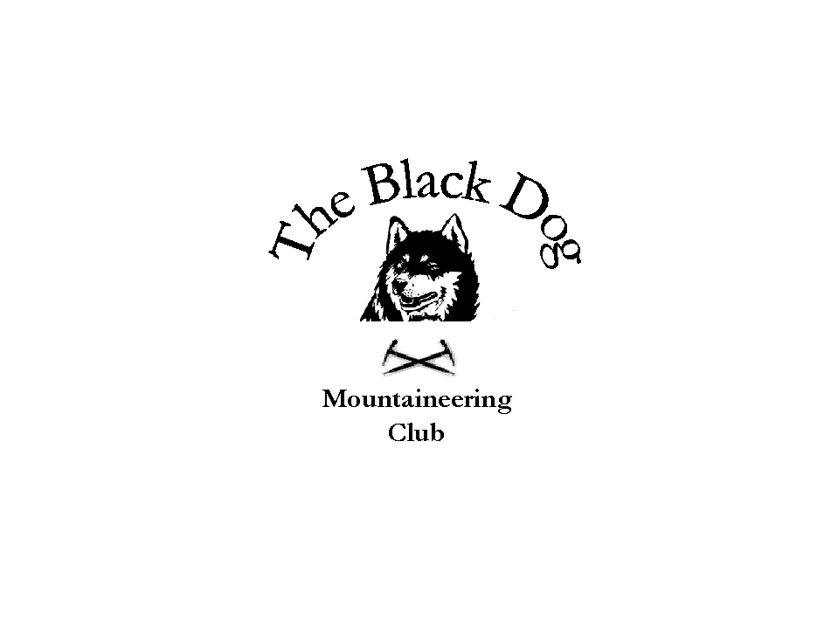

Black Dog Meet

No. 49-Kinlochewe

Date - Friday 24th-Sunday 26th March

Hills Climbed

Friday Carn a Chlamain (963m) Chris, Dave B & Andy
Sgurr an Airgid (841m) Tony, & Lorna

Saturday Meall Gorm (949m) An Coileachean (923m) Chris, Dave B & Andy
Meall a Chrasgaid (934m) Charlie, Gerry, Val & David C
Moruisg (928m) Sgurr nan Ceannaichean (915m) Steve & Fiona
Meall Lochan a Chleirich (403m) Meall an Doirein (420m) Tony & Lorna

Sunday Fionn Bheinn(933m) Charlie, Gerry, Val, David C & Andy
Ben Wyvis (1046m) Chris
Cnoc Mor (269m) Mount Eagle (256 m) Tony & Lorna

In Attendance Chris Barbour, Dave Barbour, Andy Robb, Tony Smith,
Lorna Smith, Charlie Alexander, Gerry Feeney,
Val Inglis , David Cameron, Steve Smart and Fiona O’Neill,

Weather

Friday Cold wet and stormy, gale force winds at times, some bright intervals.

Saturday Wet, but milder, got brighter towards tea-time.

Sunday Wet, mild and quite miserable all day with low cloud levels.

Snow Conditions Patchy wet snow at lower levels with deeper snow at higher levels.

Notes

Weather forecast for the weekend was terrible putting most of us off doing anything. However, on Friday Tony & Lorna started their day in Fort William and headed for Sgurr an Airgid (841m). A fine Corbett at the head of Loch Duich climbed as per the book. Good stalker's path directly from road. Easy at first but with increasing amounts of snow above about 400m. Deep snow on the plateau and very windy on the summit approach. A very fine viewpoint.

Chris, Andy & I drove to Blair Atholl with our bikes in tow and cycled 9 km up Glen Tilt to Clachghias where we left our bikes and followed a good landrover track most of the way up Carn a’ Chlamain. Once off the track we trampled through deep snow to the summit.

Charlie, Gerry, Val and David made their way up to Achnasheen with everyone arriving around tea-time.

On Saturday we were joined briefly by Fiona & Steve on their way to climb Moruisg and Sgurr Nan Ceannaichean. An early start, leaving Montrose at 5 a.m.

Tony & Lorna did Meall Lochan a’Chleirich (403m) & Meall an Doirein (420m). Two rocky little hills (Marilyns) offering excellent views of adjacent snow covered higher hills (Slioch, Fisherfield and Baosbheinn being particularly striking), down the length of Loch Maree and over the coastal area.

Chris, Andy & I drove to Grudie and once again got on the bikes and cycled the 11 km road to Fannich Lodge. We started in heavy rain and it was wet underfoot up the ridge of Meall Gorm. Again hard work through deep snow and some serious navigation to the summit. We then continued to navigate towards An Coileachan with a break in the weather occurring at the bealach where we stopped for lunch and got some well earned views before the last haul up to the 2nd summit. The bike run out was excellent with Chris zooming ahead and almost bumping into a couple of stags. Andy & I cantered home and did bump into a couple. It was Steve and Fiona who had just turned in at the bottom of the road end. What a coincidence.

Gerry, Charlie, Val & David set off in the rain from Loch a’ Bhraoin to tackle some of the Fannichs. As they headed up the footpath it was difficult to find the crossing of the river. They eventually found a suitable crossing and as they climbed up the steep icy slopes there winter skills came into play and they put their crampons on. They had some tough navigation to the top of Meall a’ Chrasgaidh.

On Sunday it was another wet start with Tony & Lorna doing Cnoc Mor (269m) and Mount Eagle (256m). Two short wet woodland detours from the route home near Strathpeffer and on the Black Isle respectively.

Gerry, Charlie, Val, David & Andy headed for Fionn Bheinn which was right on our doorstep a wet uneventful day.

I drove Chris round to Ben Wyvis carpark. It was a wet start and his ice axe was required on the climb up to the first top as the snow was melting and it was icy and very slippy underneath. He headed through wet snow along the ridge to the summit.

I drove to Corrieshalloch Gorge to take in the views before heading to Garve for a leisurely coffee and read of the papers (It was tough). As I was on my way back to Achnasheen to contact Andy my phone rang and to my surprise it was Chris who was only 20 minutes from the bottom. I turned back and got there in time for him finishing.

The Ledgowan bunkhouse was more than adequate for sleeping in but lacked the kitchen facilities that some of our Master Chefs require. Good news is that the bunkhouse is getting an extension to accommodate a better kitchen and drying room in the near future. The adjacent hotel was family run and provided excellent meals and service as well as good beer. Worth a visit if you are in the area.

Thanks to all for a good weekend.

I am arranging the next meet to Loch Tay.

Dave Barbour.

