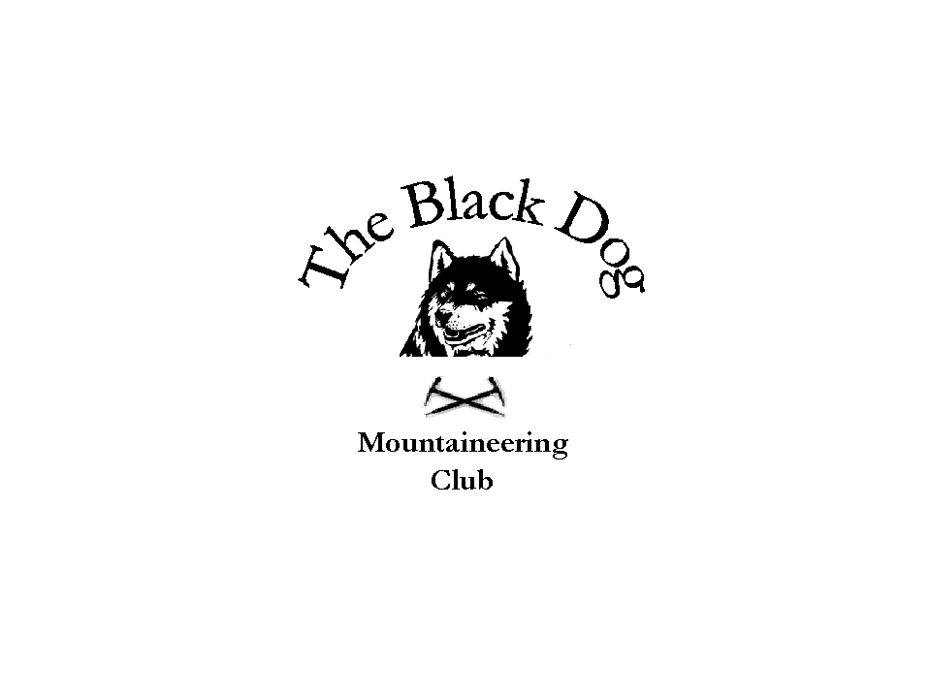

Black Dog Meet

No. 50-LochTay

Date - Saturday 29th April

Hill/s Climbed Meall Corranaich (1069m), Meall a Choire Leith (926m), Dave B, Jo B, Andy R, Ken R.
Meall Greigh (1001m), Meall Garbh (1118m), An Stuc (1118m), Ben Lawers (1214m), Beinn Ghlas (1103m) Steve S, Fiona O.
Beinn Mholach (841m), The Sow of Atholl (803m), Meall na Leitreach (775m) Alan S.
Beinn Mhanach (954m) Gerry F.

In Attendance Dave Barbour, Jo Barbour, Andy Robb, Ken Rae,
Gerry Feeney, Alan Sewell, Steve Smart and Fiona O’Neill.

Weather Fantastic. Sunny all day. Sun tan cream required.

Snow Conditions Patchy snow at high levels.

Notes

All met at Ballinluig restaurant for breakfast at 08:15 (with the exception of Steve & Fiona who had an earlier start) and discussed the hills to be climbed.

Gerry headed for Bridge of Orchy and climbed Beinn Mhanach starting from Achallader Farm, route was up Coire Acahaladair to col between Beinn an Dothaidh and Beinn Achaladair, round eastern flank of Beinn Acahaladair to watershed between Beinn Achaladair and Beinn a' Chuirn, then up to summit of Beinn Mhanach, returned by same route.

Alan headed off alone for his 3 corbets with a long walk to do all 3 but the views were excellent - from Ben Nevis, Glencoe, Lawers group to the Cairngorms.
Steve and Fiona headed off earlier as they were tackling originally 3 munros but due to the excellent weather and their great fitness levels proceeded to do all 5. They even contemplated doing another 2 on top of that but due to logistics and a long walk back to the car decided against it.
Jo, Andy, Ken & I had a brilliant day with spectacular views taken in on the way. Sunburn for Jo who forgot suntan cream. Had a pint at Ben Lawers hotel whilst waiting to see if we could see Steve & Fiona. Left for home at 4 o’clock just missing Steve & Fiona by a few minutes.

Dave Barbour

