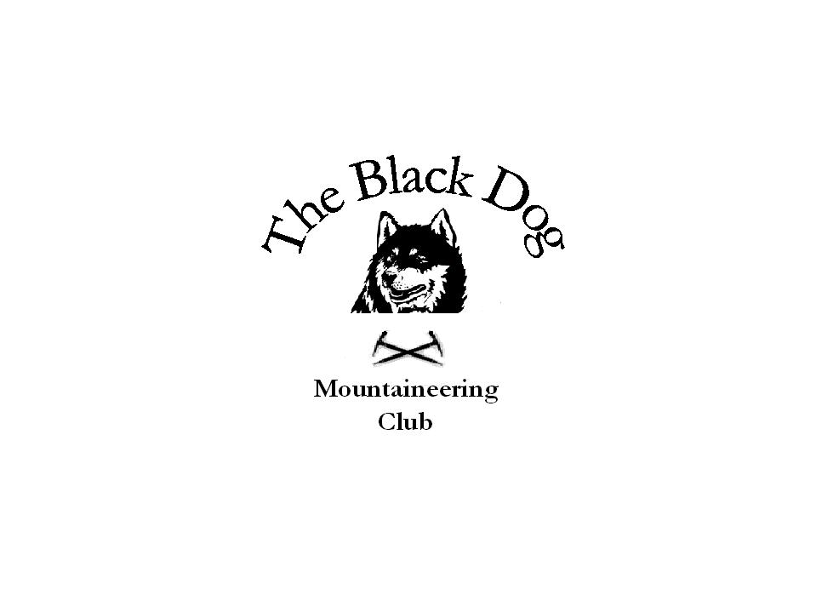
Black Dog Meet
No. 51 Skye

Date 19th 20th 21st May 2006.

In Attendance Charles Alexander Ken Rae
Dave Binnie Alan Sewell
David Cameron Russell Shanks
Pat Davis Colin Sidgwick
Steve Davis Steve Smart
Valerie Inglis Tony Smith
Fiona O’Neil John Stewart

Hills Climbed

Friday Beinn na Caillich (732m) Beinn Dearg Mhor (709m)
Pat, Steve.D, Charles, Tony
Meall Dubh (789m) Dave, Alan.
Sgurr a Mhadaidh (918m) Sgurr a Ghreadaidh (973m) Russell, John.

Saturday Healabhal Mhor (469m) Healabhal Beag (488m) Bheinn Bhac-ghlais (408m)
. Pat, Steve.D Charles, Tony. Cioch Direct, Arrow Route.
Russell, Alan.
Sgurr nan Eag (924m) Sgurr Dubh an Da Bheinn (938m)
Sgurr Dubh Mor (944m) Sgurr Alasdair (993m)
Fiona, Ken, Colin, John, Steve,S.
Sgurr Mhic Choinnich (948m)
Fiona, Steve.S
Bruach na Frithe (958m) Am Bastier (935m)
Dave, Val, David.

Sunday The Storr (719m) Hartaval (668m)
Pat, Steve.D, Charles, Tony.
Bhastier Tooth (915m) Am Bastier
Fiona, Alan, Russell, Steve.S
Bruach na Frithe,
Fiona, Russell, Steve.S.
Sgurr nan Gillean (965m)
Fiona, Steve.S. Colin, John, Ken, Dave.

Weather Friday-Misty & damp on Meall Dubh, but bright
later on Skye.
Saturday-Brilliant!!!!!!!
Sunday-Cloud cover stayed above the tops, another
cracking day.

Notes Skye had an onslaught of Black Dogs From Friday to Sunday.
While Pat, Steve D, Charles and Tony tackled the hills overlooking
Broadford, Dave and Allan had a leisurely stroll over cropped heather
to the Corbett Meall Dubh above Glen Moriston.
Russell and John had made it to Glen Brittle and the main Cuillin Ridge,
Sgurr a Mhadaidh and Sgurr aGhreadaidh by An Dorus a fine narrow
Gully between the two mountains. Everyone else arrived on Skye
later after work. Plans for Saturday were made over a meal and
some soft drinks, I think the chef was a bit harassed but the food did
arrive. The strumming of guitars could soon be heard as the Black Dog
Karaoke Machine warmed up, always seems to work better after half a
gallon of special lubricant (Guinness I think its called), some fine tunes
were murde… played by Alan & Dave as quite a few sang along.

Saturday started fine and clear, Loch Harport was flat calm as the Black
Dog cruiser cut the water (Fiona & Steve in canoe) for an early morning
paddle. After breakfast we split into four groups and scattered over
Skye. Pat, Steve.D, Charles, and Tony headed for Mcleods Tables to the
west near Dunvegan, twin flatted topped hills and the near neighbour
Bheinn Bhac-glais.
Alan & Russell donned their slippers for Cioch Direct (severe) &
Arrow Route (v diff ) on the superb Cioch Slab, finishing by going
underground up eastern gully.
Fiona, Ken, Colin, John & Steve.S. had the long trek round to Coire a
Ghrunnda before climbing to Sgurr nan Eag. After that it was mountain
after brilliant mountain round to the Sgurr Alasdair. Part of the way
down the stone shute our group split, Fiona & Steve.S. heading off for
Sgurr Mhic Choinnich by Collies Ledge while Ken, Colin, & John
continued down the” pleasant “stone shute to Coire Lagan.

Val, Dave,& David were at the north end of the ridge on Bruach
na Frithe & Am Bastier avoiding the “Baaad Step” by the Lota
Coire ledge route.
Our meal was followed by more music but not of the top notch
stuff we are used to from “The Karaoke Machine”. Most were
driven to their rooms by the din apart from a few who chose
to adopt the local remedy for crap music, Talisker which numbs
the senses nicely.

Sunday started the same weatherwise as the Black Dog Cruiser
again hit the water for the sea air wakener.
Dave, Ken, Colin & John went for a stroll up Sgurr nan Gillean
by the tourist route.
Pat, Steve.D, Charles & Tony went north of Portree to The Storr
& Hartaval on the Trotternish Ridge.
Fiona, Alan, Russell & Steve.S went along the Sgurr a Bhastier
Ridge to Bealach nan Lice where Alan waited while the rest scurried
out to Bruach na Frithe and back. From the bealach it was up the
Bhastier Tooth by Naismiths route then on to Am Bastier.
From the Bealach a Bhastier we split, Alan & Russell descending
to Coire a Bhastier & Fiona & Steve.S ascending Sgurr nan Gillean.

Thanks to all who made it to Skye for a brilliant weekend.

The next meet is 10th-11th June Fisherfield
Contact Steve Davis.

Steve Smart.

