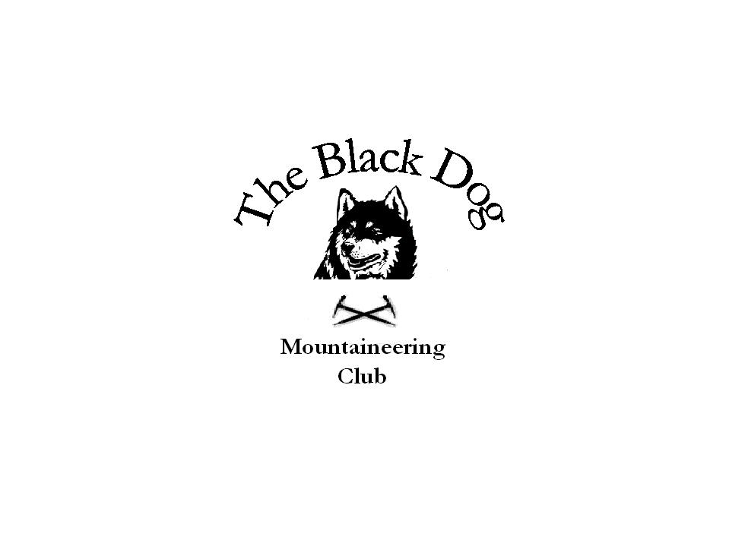
Black Dog Meet

No. 52 Fisherfield

Date 9th-11th June 2006

In attendance Party A Jo Barbour Chris Barbour
Dave Barbour Gerry Feeney
Keeny Rae Andy Robb
Party B Steve Davis Lorna Smith
Tony Smith

Hills climbed

Friday Party A - Beinn Ghoblach, Cnoc a’Bhaid-rallich

Saturday Party A - Beinn Dearg Mor, Beinn Dearg Bheag

Party B - Beinn a' Chlaidheimh, Sgurr Ban, Mullach Coire Mhic Fhearchair, Beinn Tarsuinn

Sunday Party B - A'Mhaighdean, Ruadh Stac Mhor

Weather

Friday Hot and sultry all day

Saturday/Sunday Sunny and hot, although a bit windy at times along the ridges and tops,

Report

Party A arrived at Badrallach at lunchtime on Friday and set out up towards the two hills to the north. It was very hot and getting up the first hill was rather tiresome. Nevertheless we reached the top with great views all around but particularly towards An Teallach. Going up and down to Beinn Ghoblach was easier as was the descent to the two lochans where there was extra water which we all needed badly. Took a descending traverse line back to the bothy.
The remainder of the group arrived at various times on Friday evening, and the presence of a rather selfish family group of Germans(?) made the bothy rather unpleasant, and bivvying out in the field was a preferred option for some!
All set off from Coire Hallie car park about 8.30 for what turned out to be an epic day in many senses. The sun was beating down on us as we headed along the land-rover track with spirits high at what was shaping up to be a beautiful day. After a brief stop for a group photo in the shadow of the impressive An Teallach, Party A went down to Shenavall and Party B continued along the landrover track to cross the Abhainn Strath na Sealga.

Given the heat Party B opted to approach Beinn a' Chlaidheimh along the easier Creag Ghlas ridge then up a defile towards the summit ridge. Everyone was feeling the effects of the heat and steady climb with more stops than usual being taken. After what seemed like an age they reached the summit, the views all around were magnificent.
They then set off on the long trek to Sgurr Ban. At the summit they had the misfortune to meet up with a group heading in the opposite direction who were somewhat disparaging about the time taken to reach Sgurr Ban and doubted if they would make it to their bivvy spot at the col between Beinn Tarsuinn and A'Mhaighdean.
It must be admitted that their hearts sank on seeing the climb to Mullach Coire Mhic Fhearchair but after a rest to fuel up on food, reached the summit in just half an hour. This gave them a lift and the determination to go on to our bivvy site, however by this time everyone was tired and after a long plod, they finally made camp at about 9.30 pm, a very long day! After a meal and a few swigs from hip flasks, it was off to bed.

Meanwhile Party A continued on past Shenavall to Larachantivore where they set up a rudimentary camp before setting off up the steep western slopes of Beinn Dearg Mor. Lorna’s knee was bothering her and she turned around rather than risk further trouble. Tony and Steve continued up the hill and reached the top thankful that to have taken as much water as they had. The descent to Beinn Dearg Bheag was steep and loose and the climb up was trying – thoughts went out to party B, whom we knew must have been suffering with their 4 ascents! They descended to the lochan under BDM, which was a glorious place in our dehydrated state, and having fully rehydrated they set off back to the tents.

After a comfortable night's sleep Party B were up about 06.30 for breakfast. They set off for A'Mhaighdean.about 7.30 under a dull sky which cleared as the day went on. giving more hot walking conditions. Again they were rewarded with great views from the summit.After setting off towards Ruadh Stac Mhor they lost our way a bit but managed to get down to the col without much difficulty. They headed up a loose path to the summit of Ruadh Stac Mhor , the last of the "Fisherfield six", and felt well pleased with themselves and the hip flask came out again. They "only" had to walk back to the cars by way of Gleann na Muice Beag and Shenavall to get home. The climb from Shenavall back to the land -rover track was punishing, coming at the end of two days hard walking.
Party A also got up early – ca.05.00 in their case and had the same pleasure on the walk out – any thoughts off more hills had disappeared with the sun!

A really great weekend spoiled rather by the intense heat, but one which we shall all remember for many a long year.

PS Any rumours that Chris had to loan out his rucksack for parts of the trek to other members of the group are entirely unfounded.

Steve Davis

