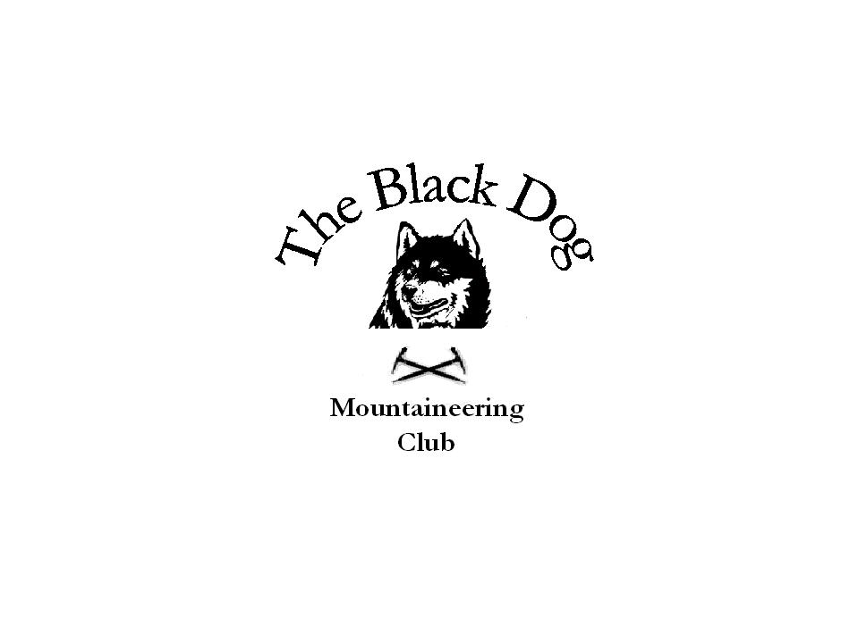Black Dog Meet

No. 54 “Glencoe”

Date – Friday, Saturday & Sunday 22nd, 23rd & 24th September 2006

Hills Climbed | Beinn Maol Chaluim (907m)  Sgorr Dhearg (1024m), Sgorr Dhonuill (1001m)  Fuar Bheinn (766m), Creach Bheinn (853m)  Stob Ban (977m), Stob Choire Claurigh (1177m), Stob Coire an Laoigh (1116m)  Glas Bheinn (501m)
In Attendance | Dave Barbour, Alan Sewell, Russell Shanks, Ken Rae, Dave Cameron, Val  Inglis and Steve Davis
Notes | The group met up on Friday evening at the hostel with some having stretched their arms and legs on the way over. Alan and Russell had been climbing in the Cairngorms (don’t ask why, when the meet was in Glencoe) and had completed “Savage Slit”, whilst Steve had climbed Beinn Maol Chaluim in Glen Etive.  Saturday dawned clear and bright – another glorious day. Dave, Ken and Russell climbed the two Munros on Beinn a’Bheithir, whilst Alan and Steve tackled the circuit of Beinn na Cille, Fuar Bheinn and Creach Bheinn in Ardgour – a deceptively long day! Val and Dave went to the Grey Corries and climbed Stob Ban, Stob Choire Claurigh and Stob Coire an Laoigh before heading home early.  Sunday was initially clear but the rain came on and made for unpleasant conditions. Alan and Russell climbed the Severe “Flying Dutchman” before it became too wet, but Ken and Dave failed in their attempt on Beinn Mhanach (wimps!). Steve managed a very small relative hill on Rannoch Moor – Glas Bheinn.  Apologies for the tardiness of this report but better late then never.  Another great weekend meet.  Pat & Steve
Next Meet | Crieff 28th October 2006

