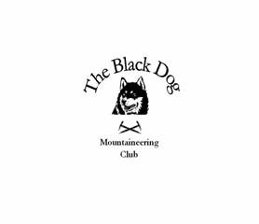

Black Dog Meet
No. 55 Crieff

Date – 28th October 2006.

Hills Climbed Ben Challum (1025m)
Auchnafree Hill (789m)

In Attendance
Gerry Feeney
Charles Alexander
Fiona O’Neill
Steve Smart

Log

Gerry and Charles climbed Auchnafree Hill a Corbett on the east side of Loch Turret near Crieff. This was a fairly straightforward walk mostly on tracks. Thick cloud and resulting poor visibility made finding the summit a navigation exercise but we succeeded in locating it. Weather was showery with low cloud and a stiff breeze at the summit

Steve and Fiona headed further west to Climb Ben Challum a Munro on the east side of the A85 between Crianlarich and Tyndrum. Rout was over railway line then heading NE directly up the side of the hill to the 997m top south of the summit, the ridge to the south top was very windy. After reaching the summit, rather than retrace the route up, they dropped down into the Gleann a Chlachain then contoured round back to the start

Next meet 25th November “Rannoch”

Gerry Feeney

