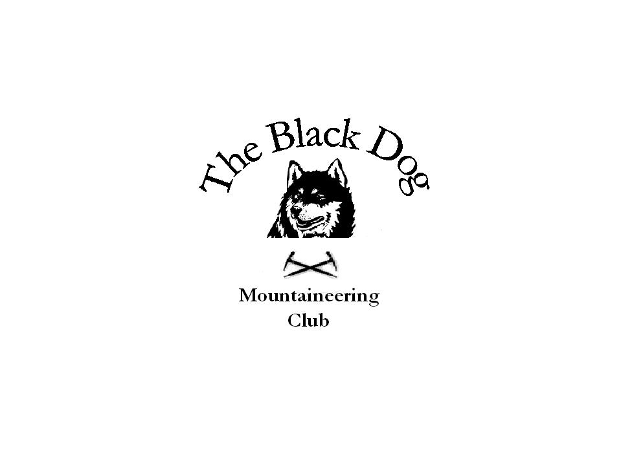Black Dog Meet
No. 56 “Clova”

Date. Saturday 9th December 2006

Hills Climbed. Mayar (926m), Driesh (947m)
Cairn Damff, Craig Mellon, Cairn Broadlands

In Attendance. Charles & Jean Alexander, Dave & Jo Barbour, Fiona O’Neill, Gordon & Moira Rankin, Andy Robb, Steve Smart, Lindsay Wyllie and Lorna & Tony Smith

Notes. A clear and frosty morning as we set off from the usual car park through Glendoll towards Coire Fee. The path up by the burn is newly reconstructed and provides good access to the open hill (apart from the icy patches).
At the top of the corrie Jean and Moira turned back (more time to sample the offerings of the Clova Hotel) and Lindsay (plus dog) set off North to cross to Jock’s Road.
The rest of us continued to the summit of Mayar in very windy and cold conditions where we stopped (briefly) for lunch.
By the time we had reached the Kilbo path the wind had if anything increased still further and only Andy, Lorna and Tony continued to Driesh as originally planned.
Meanwhile Fiona and Steve headed NW up Jock’s Road and the NE before the shelter to Cairn Damff. Thereafter they went across the plateau and down Strone ridge and back along the landrover track. A good route on semi-frozen ground but otherwise would be very boggy in places.

All eventually gathered for a pint in the Clova Hotel (and, of course, later for the meal at the Hillside Hotel) to muse over the day and the year’s walking.

Here’s to 2007.

Tony Smith

Next Meet. Glenshee winter skills weekend 27th & 29th January 2007. Mike organising

