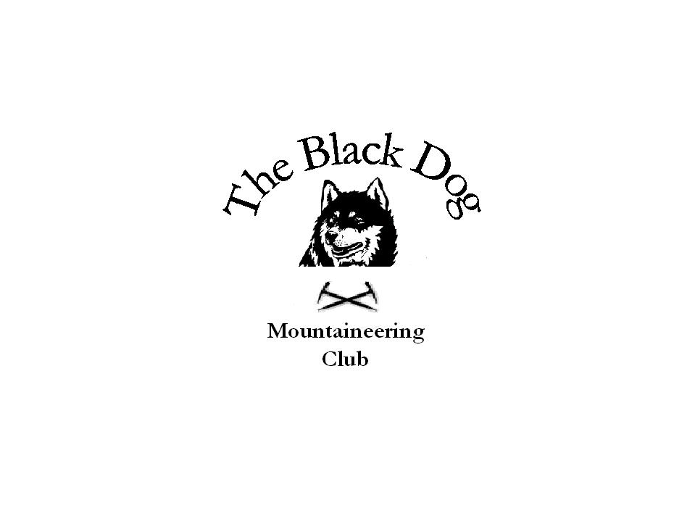Black Dog Meet

No. 57 “Glenshee Winter Skills”

Date - Saturday 27th – Sunday 28th Jan 2007

Hills Climbed | Saturday All - Winter Skills on Glas Maol  Carn a Gheoidh & Carn Binnien (Top) Alan Sewell  Sunday – Mike (MRT Ex on Glas Maol)  Carn an Turic – George S and Colin
In Attendance | Dave Barbour, Gerry Feeney, Tony Smith , Alan Sewell , Mike McLaggan , Iain Macdonald &family , Kirsty Mclaren , George Skinner , Colin Sidgwick , George Norman , Val Inglis , Davie Cameron , Stewart Richardson , Jim Donaldson , Graham Wyllie , Andy Robb , Ken Rae
Notes | Good accommodation and home cooking at Gulabin Lodge .Thanks to Daz and his family.  Snow Conditions pretty mixed, reasonable cover but quite soft all over and didn’t get a chance to put crampons on….  Had a chance to look at snow anchors and the use of the rope. Hopefully have a chance to look at this in detail next year.  Weather, a bit overcast but tops were clear with sunny spells.  Graham Wyllie’s dietary requirements (or lack of them) = 1 big plate of roast potatoes on their own and no breakfast !!!!!!  Gerry’s dramatic rescue from the toilet cubicle at 130am (not sure what was more dangerous? the climbing out of the cubicle or the glare from the pyjamas!!)  Colin’s – “What a state we’re in” of the Union address !!!!!! got a debate going late on Saturday night………  Everyone enjoyed the day and took something from the session. Thanks to Jim and Stewart for helping out.  Mike McLaggan (for a change) 29-01-07
Next Meet | Schiehallion Sat 24th Feb - Organiser Alan Sewell

