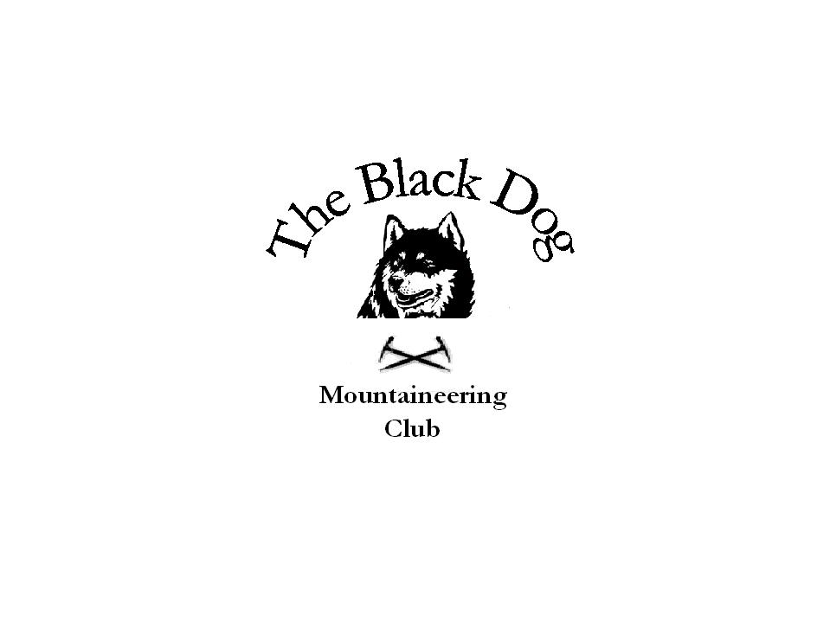Black Dog Meet

No. 58 “Schiehallion”

Date - Saturday 24th February 2007

Hills Climbed | Schiehallion  Meall Tairneachan, Farragon Hill
In Attendance | Gerry Feeney, Charles Alexander , George Norman, Colin Sidgwick, George Skinner, Kirsty Mclaren, Ken Rae, Davie Cameron, Valerie Inglis
Notes | Met up at the “Motor Inn” in Ballinluig for breakfast before setting off for the hills.  Snow was pretty scarce , only patches of soft snow  Colin, George Skinner, Kirsty, Ken, Davie and Val climbed Schiehallion making steady progress on a well constructed path. Although Kirsty, Ken, Davie and Val ‘s start to the climb was delayed when they missed the sign post marked “Schiehallion Road” and started to head for Tummel Bridge !  Visibility was poor with occasional rain.  Gerry, Charles and George Norman climbed the Corbetts Meall Tairneachan, and Farragon Hill. The route was mostly on good tracks used for access to the Byrites mine. The difficulty was when we had to find our way from the first to the second Corbett. Poor visibility (about 50 yards or less at times) meant our navigation skills were put to the test. A test which we looked like failing until we made use of our GPS, a great invention!
Next Meet | Ullapool 24th and 25th March - Organiser Charles Alexander

