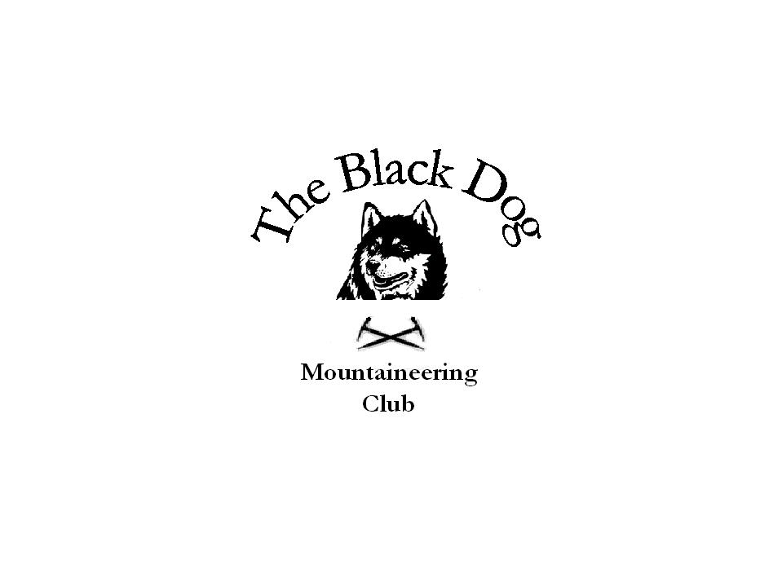Black Dog Meet

No. 59 “Ullapool”

Date – Friday, Saturday & Sunday 23rd, 24th & 25th March 2007

Hills Climbed | Friday  Meall Doire Faid (Pat, Steve, Tony and Charles)  Meallan nan Uan and Sgurr a’Mhuillinn (Alan)  Saturday  Quinaig (Pat and Steve)  Canisp (Tony and Alan)  Beinn Reidh (Tony)  Glas Bheinn (Alan)  Sgurr nan Each and Sgurr nan Clach Geala (Charles, Gerry, Dave C, Val and George)  Beinn Liath Mhor Fannich and Sgurr Mhor (Dave B, Chris, Ken and Andy)  Seana Bhraigh (John)  Sunday  Meallan Liath Coire Mhic Dhugaill (Pat, Steve, Tony and Charles)  Tom Ban Mor (Val, Dave C, Gerry, Andy and George)  Mullach Clach A’Blair (Dave B, Chris and Ken)  Geal Charn (Nethy Bridge) (Alan)
In Attendance | Pat and Steve Davis, Tony Smith, Charles Alexander, Alan Sewell, Val Inglis, Dave Cameron, Gerry Feeney, Andy Robb, George Norman, Dave Barbour, Chris Barbour, Ken Rae and John Stewart.
Notes | The 14 members present stayed at the Backpackers Hostel, Ullapool. Accommodation was good, no longer “work in progress”.  The “Ceildh Place” food and beer were very good, highly recommended. Not the cheapest in town but very good value and pleasant staff.  Weather on Friday bright and sunny and reasonably warm for time of year. The Friday strolls were uneventful, Alan caught up with the others in the car park near Corrieshallach gorge and we proceeded to the Backpackers where Val and Dave were already installed in the driver’s room. This ended any overbooking problem, thanks to you both. The rest of the party arrived during the evening, dining at the local chippie.  Saturday weather was glorious, warm and sunny even on the tops, no wind. John had a long day (as expected) but returned a happy man.  Charles et al had a great day with an interesting crossing of some steep icy slopes. Crampons would have made the crossing easy but with only one pair among five people, cutting steps was the order of the day. This is a learning point for spring walking! The huge frog orgy in the pools in the path added interest to the walk out.  Sunday weather was mixed. Cold, windy and misty in the north, beautiful day further south. Gerry et al set off to do Am Faochagach but were behind schedule and decided to turn back as it would have been very late before they got back to Montrose. Other objectives were achieved.
Next Meets | Ben More/Stob Binnein 21st April. Organiser Chris Barbour (cancelled)  Skye 11th – 13th May. Organiser Steve Smart

