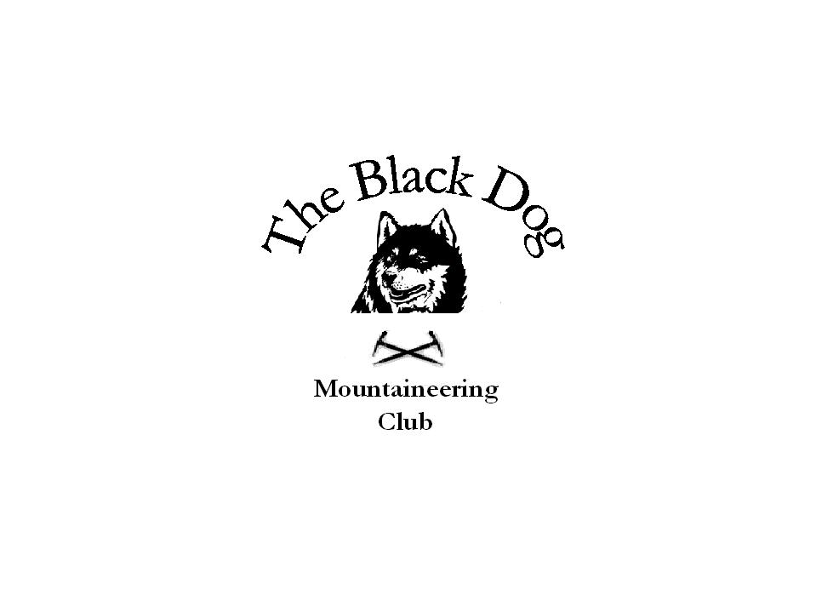Black Dog Meet

No. 60 “Ben More”

Date – Saturday 21st April 2007

Hills Climbed | Creag na Eighe (Tulliemet)
In Attendance | Alan Sewell  Mike McLaggan  Stewart Richardson  Darren Morgan (guest)
Notes | Only George Norman and Gerry had expressed an interest in going hillwalking so the walking meet was called off.  However some of our members opted for climbing.  Routes climbed on Creag na Eighe, in dull but dry weather, were  Woodworm - V Diff  Jugs - V Diff  Jaggy Bunnets - Severe 4a  'A Voitre Sante' Dickie - Severe 4a  Raptors Chimney - Severe 4a
Next Meet | Skye 11th – 13th May. Organiser Steve Smart

