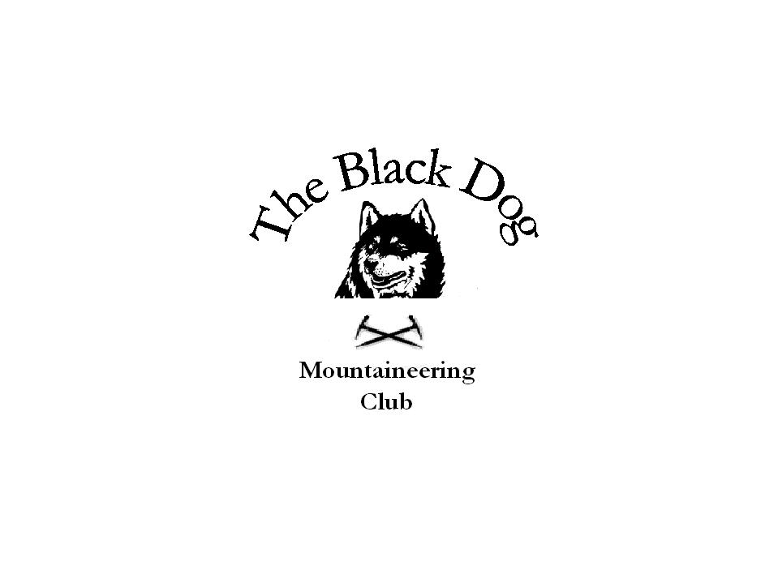Black Dog Meet

No. 61 “Skye”

Date – Friday, Saturday and Sunday 11th, 12th & 13th May 2007

In Attendance | Charles Alexander, Dave Binnie, Pat Davis, Steve Davis, Gerry Feeney,  Fiona O Neill, Alan Sewell, Steve Smart, Lorna Smith, Tony Smith and John Stewart.
Hills Climbed | Friday  Sgurr Gaorsaic (839m) Lorna, Pat, Tony, Steve D & Charles.  The Saddle (1010m) Alan & Dave.  Sgurr na Sgine (945m) Dave.  Spidean Dhomhuill Bhric (939m) Alan.  Sgurr Leac nan Each (919m) Alan.  Saturday  An Stac (954m) Alan, Fiona & Steve S.  Inn Pinn (986m) Alan, Charles, Fiona, John & Steve S.  Sgurr Dearg (978m) Alan, Charles, Fiona, Gerry, John & Steve S.  Sgurr Mhic Choinnich (948m) Fiona, John & Steve S.  Beinn a Bhraghad (461m) Lorna, Pat, Steve D & Tony.  An Cruachan (435m) Lorna, Pat, Steve D & Tony.  Sunday  Clach Glas (786m) Fiona & Steve S.  Bla Bheinn (928m) Fiona & Steve S.  Beinn na Cro (572m) Charles, Lorna, Pat, Steve D & Tony.  Beinn nan Carn (301m) Tony.  A Ghlas-bheinn (918m) Gerry & John.  Beinn Fhada (1032m) Gerry & John.
Weather | Friday-Skye was a bit wet and misty. Mainland was fine.  Saturday- Misty around the tops early on but lifted as the day went on.  Sunday- Fine clear day on Skye with a chilly breeze. Showers on the mainland, snow on the tops.
Notes | Lorna, Pat, Charles, Steve D, & Tony stopped off at Morvich on the way over to Skye to bag the Corbett Sgurr Gaorsaic. Alan and Dave weren’t all that far away tackling the Forcan (better watch my spelling) Ridge on route to The Saddle. Here they split, Alan taking a big drop for two tops and Dave going for Sgurr na Sgine. John and Gerry aborted their mission to Sgurr Alasdair due to the weather.  Eventually everyone was at The Old Inn at Carbost for some food and a blether followed by some tunes from the Alan & Dave Combo.  Saturday started a bit overcast but it got better as the day went on.  Lorna, Pat, Steve D and Tony headed for a pair of Marilyns above Glen Brittle. They started having a nice stroll on a good track but ended up having to battle through brambles and a dense fir plantation. They were rewarded with the sighting of Dotterel on An Cruachan and superb sea views, which is one of the bonuses of Skye.  Fiona, Charles, Alan, Gerry, John and Steve S wandered up into Coire Lagan then sauntered up the An Stac screes. Here they split; Fiona, Alan and Steve S went up An Stac direct to end up on Sgurr Dearg. The others took the trade route to Dearg. Alan set up the rope after climbing the west ridge of the Inn Pinn. Fiona, Charles, John and Steve S topped the Pinn, for  Charles and John it was their first ascent. The descent to the top of the screes was a bit dodgy, where they again divided. Fiona, John and Steve S went over to Sgurr Mhic Choinnich before following the others back down to the beach.  Dave “New Shoes” set off on his own back to Glen Sheil for the 3 Munros Carn Ghluasaid, Sgurr nan Conbhairean & Sail Chaorainn. A good round of 3 fine mountains.  After everyone was fed the guitars came out again and a few songs were sung along with the usual refreshments.  Sunday morning saw Lorna, Pat, Charles, Steve D and Tony head round to Loch Slapin for some more Marilyns. 5 climbed Beinn na Cro from the head of the loch then later Tony set off on his own for Beinn nan Carn south of Broadford.  Fiona & Steve S were also in the same area to climb Clach Glas and Bla Bheinn. Clach Glas was ascended by Sids Rake (Slapin the Face Variation) a cracking scramble with some interesting route finding. Then on to Bla Bheinn by Scuppers Gully.  Gerry & John had a long day on the mainland taking in A Ghlas-bheinn & Beinn Fhada.  Alan & Dave had a relaxing ( I think) day on Skye.  Just a wee note. Big thanks to Alan Sewell for again giving up his own precious Skye time to scale the Inn Pinn. Thanks Alan.  Steve Smart
Next Meet | Knoydart 22nd to 25th June. Organiser Steve Davis

