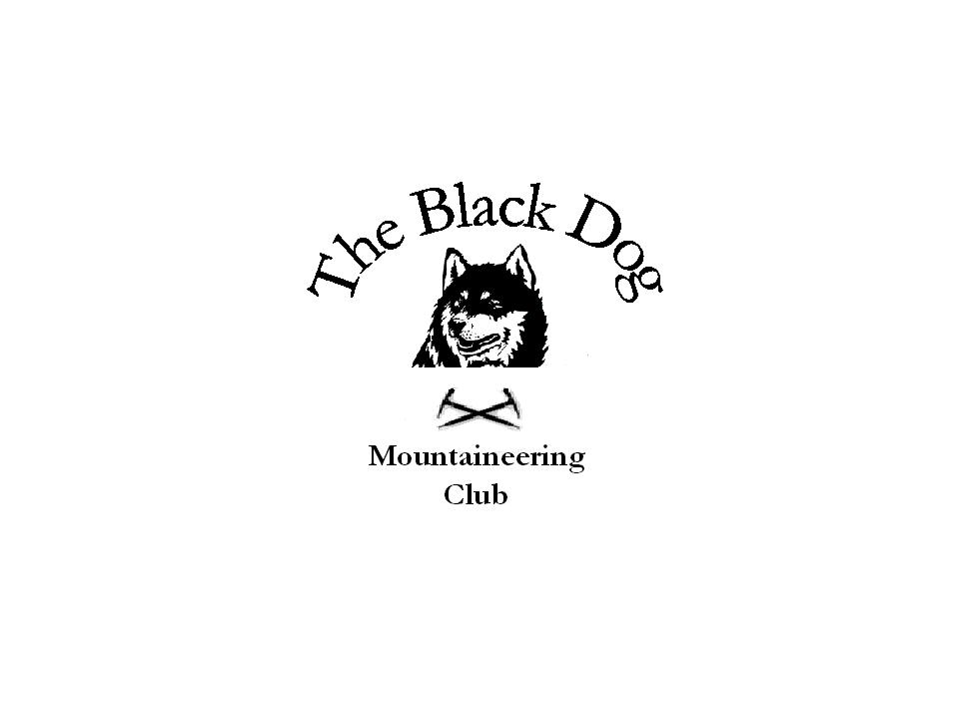Black Dog Meet

No. 62 “Knoydart”

Date – Friday 22nd to Monday 25th June 2007

In Attendance | Steve Davis, Pat Davis, Jenny Davis, Alan Sewell, Tony Smith, Lorna Smith, Dave Binnie, Val Inglis, Dave Cameron, John Stewart, Charles Alexander
Hills Climbed | Sgurr Coire Choinnchean, Druim na Cluain-airighe, Meall Buidhe, Luinne Bheinn, Beinn Buidhe, Ladhar Bheinn, Beinn na Caillich
Weather | Good with sunny intervals. Misty on the tops.
Notes | The group arrived at the hostel in Inverie in two parts. Alan, Dave and Charles spent a pleasant afternoon on the Marilyn – Druim na Cluain-airighe, whilst Pat, Jenny and Steve took in the Corbett directly above Inverie – Sgurr Coire Choinnchean. By the time we all returned the rest had arrived.  Saturday was a less pleasant day but the main group did a traverse of Meall Buidhe and Luinne Bheinn – highlighted by Dave and Jenny yomping back to the hostel from the Mam Barrisdale! Steve and Pat set off with the main group, but turned off up to the Mam Uchd for the traverse of Beinn Buidhe. Tony and Lorna climbed the Marilyn, and were the only ones to get a view from the top that day.  Sunday dawned with the party being a little worse for wear – from the walks and the drink! The main group did a short round of Ladhar Bheinn- up the NW ridge and return, Steve and Pat went up Beinn na Caillich, and Tony, Lorna, Alan and Dave walked around the peninsular via Airor and Inverguseran.  We ate and drank in The Old Forge on Friday and Saturday – enlivened by a good singsong on the latter, and ate in the Restaurant on Sunday.  We all returned on the Monday morning ferry to Inverie.  Another great outing to the far west.
Next Meet | Inchree 27th to 29th July. Organiser Gerry Feeney

