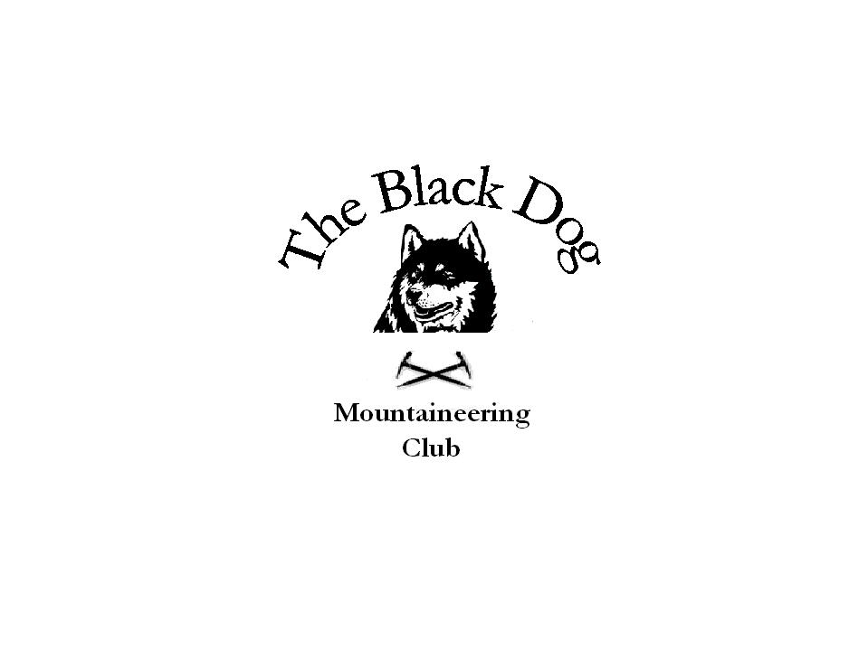Black Dog Meet

No. 63 “Inchree”

Date – Friday, Saturday and Sunday 27th, 28th & 29th July 2007

In Attendance | Gerry Feeney, Val Inglis, Kirsty McLaren, George Norman, David Roberts, Alan Sewell, Colin Sidgwick, George Skinner and Tony Smith
Hills Climbed | Friday  Creach Bheinn (853m) Alan and Tony  Saturday  Beinn A’ Chrulaiste (857m) Gerry  An Gearanach (982m), Stob Coire a’ Chairn (981m), Am Bodach (1032Sgurr a’ Mhaim (1099m). George, Colin & George  Stob a' Bhealach an Sgriodain (770m) Tony, Alan, Val and Kirsty  Sgurr Ghuibhsachain (849m) and Sgor Craobh a’ Chaorainn (775m) Alan, Val and Kirsty  Stob Mhic Bheathain (721m) Tony  Sunday  Sgurr Eilde Mhor(1008m( Binnein Beag (940m), Binnein Mhor (1128m) and Na Gruagaichean (1055m) Gerry and Val  Meall Lighiche (772m) Alan  Sgorr a’ Choise (663m) and Meall Mor (747m) Tony  Beinn Fhionniaidh (959m) David plus son and friend
Weather | Friday was characterised by some heavy showers.  Saturday was more of the same with those in Glenfinnan probably getting the worst of it. Conditions underfoot were soggy and slippery with some of us ending up rather wet and muddy  Sunday was a better day with showers less heavy and the cloud lifting above the summits in late afternoon.
Notes | The hostel was adequate for our needs but would have been uncomfortable/ inconvenient had we filled it up (capacity 19)  We were joined by David Roberts and his son and friend on the Saturday night  We have a club meeting on 21st August in the Black Abbot to discuss the Ben Alder meet, the following Sunday, plus any other business.  Gerry Feeney
Next Meet | Ben Alder (using bikes) Sunday 26th August. Organiser Dave Barbour

