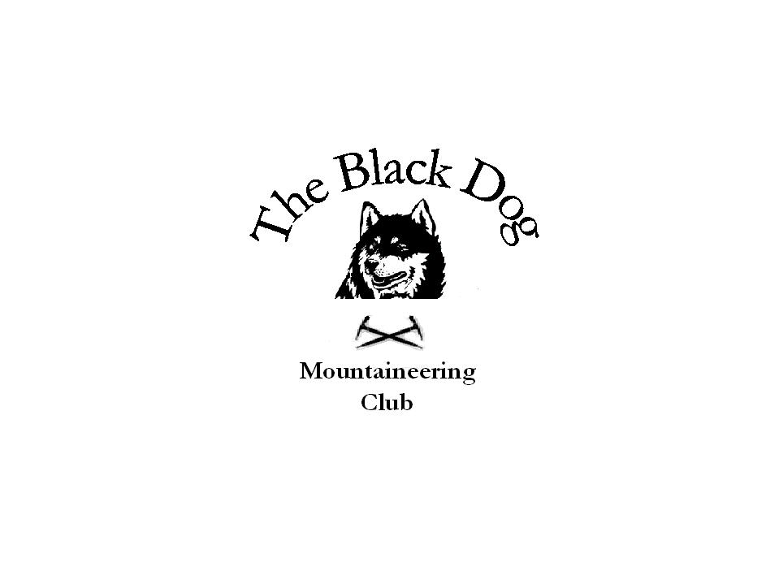Black Dog Meet

No. 64 “Dalwhinnie”

Date – Sunday 26th August 2007

In Attendance | Alan Sewell, Charlie Alexander, Ken Rae, Jo Barbour, Chris Barbour and Dave Barbour
Hills Climbed | Ben Alder and Beinn Bheoil Charlie, Ken, Jo, Chris and Dave  Fara (Dalwhinnie) and Meallach Mor (Tromie Bridge) Alan.
Weather | Weather generally ok. Cold on top of Ben Alder as the cloud rolled in. Clear views from the top on Beinn Bheoil right down Loch Ericht.  Alan’s weather was ok with the tops clear and some views.
Notes | The group all started off together in Dalwhinnie for breakfast. We proceded to cycle up the well kept road for 3km where Alan left for Fara. The rest of us continued to Culra bothy where we left the bikes and started the climb up Ben Alder. We continued onto Beinn Bheoil and along the ridge to our descent to Culra bothy. The cycle out was enjoyed by all.  Time taken 9hrs.  Alan’s notes: The cycle up Glen Tromie was good - tarred road for all 10km. Back home by 5.00pm  Steve and Fiona went out on Saturday and they did the 4 munros across from Ben Alder and a top. They also cycled in.
Next Meet | Meall Gheordie (John’s “Compleation”) Saturday 29th September. Organiser John Stewart

