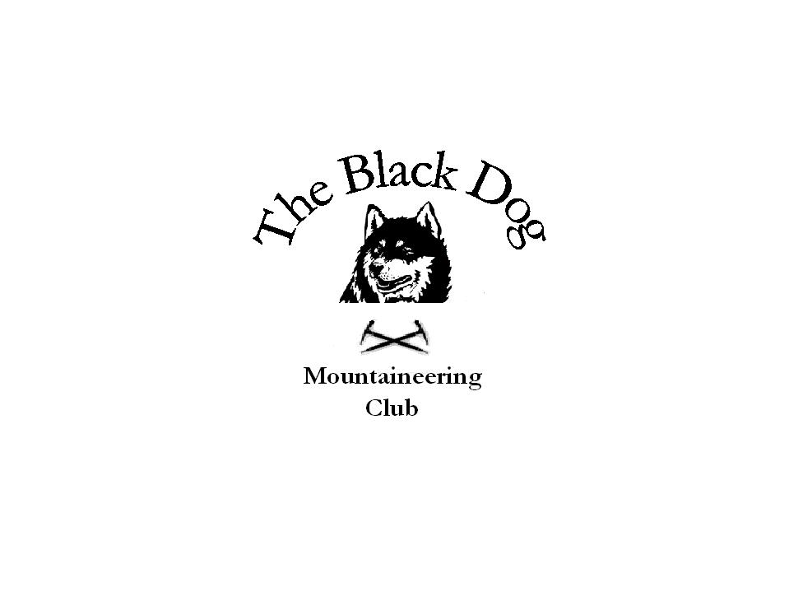Black Dog Meet

No. 65 “Meall Ghaordie” (John’s ‘Compleation’)

Date – Saturday 29th September 2007

In Attendance | Members: Jean Alexander, Charlie Alexander, Jo Barbour, Chris Barbour, Dave Barbour, David Cameron, Jenny Davis, Pat Davis, Steve Davis, Gerry Feeney, Valerie Inglis, Mike McLaggan, Jimmy Mains, George Norman, Fiona O’ Neill, Alan Sewell, Lorna Smith, Tony Smith, John Stewart and Lindsay Wyllie  Guests: Jane Attfield, Andy Attfield, Rowan Attfield(age 5), Seanaigh Attfield(7), Dierdre Latimer, Ritchie Latimer, Abbie Latimer(8), Jessica Latimer(5), Martin McFie, Chris Mitchell, Chris Rushbridge, Angela Rushbridge, Gillian Thomson, Kenny Thomson, Woody Thomson(5), Jake Thomson(4), Rosie Tindal, Alan Tindal and 4 (brown) dogs
Hills Climbed | Meall Ghaordie (1039m) (all)  Beinn nan Imirean (849m) (Alan Sewell)
Weather | Mist on the summit. No wind. Cold.
Notes | “This was my ‘compleation’ hill and the turnout was fantastic, thank you all for coming. Also thanks to the club members for helping me achieve what a few years ago seemed impossible.”  John
Next Meet | Glen Shiel Friday 26th to Sunday 28th October. Organiser Dave Barbour.

