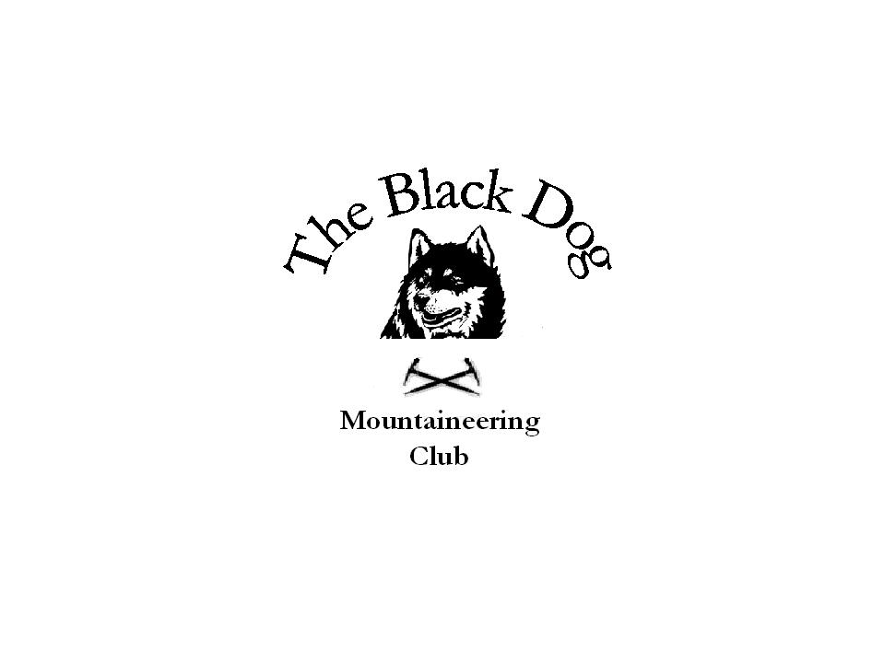
Black Dog Meet

No. 66 Glen Shiel

Date 26th-28th October 2007

In attendance Jo Barbour Pat Davis
Dave Barbour Steve Davis
Kenny Rae Andy Robb
Tony Smith Charlie Alexander
Dave Cameron Val Inglis
Alan Sewell Lindsay Wyllie
George Norman Fiona O’Neill
Steve Smart

Hills climbed

Friday Beinn Damh (Torridon) – Steve D, Pat D, Charlie A
Beinn Loinne – Alan S, Tony S
Carn Ghluasaid – Lindsay W
Geal Charn and A'Mharconaich – George N

Saturday Sgurr na Ciste Duibhe, Sgurr na Carnach and Sgurr na Fhuaran – Charlie A, Dave B, Jo B, Dave C, Val I, Ken R, Andy R, Fiona O, Steve S
Sgurr nan Eugallt and Meall nan Eun – Tony S
Beinn nan Caorach and Beinn na h-Eaglaise – Alan S, Pat D, Steve D
Walk to Surdalan Bothy – Lindsay W

Sunday Sgurr na Sgine – Dave B, Jo B, Ken R, Andy R, Val I, Dave C
Beinn Damh (Torridon) – Lindsay W
Buidhe Bheinn – Tony S, Alan S

Weather

Friday Wet and Drizzly cleared in afternoon for some views.

Saturday Torrential rain, Gale force winds

Sunday Torrential rain

Report

Stayed at Kintail Outdoor Centre, Morvich Farm.
The accomodation was excellent. It had all the facilities you required after climbing the hills in the atrocious weather conditions we encountered.
It was good to still have as many people turn up considering the weather forecast.
It was necessary to drive to the hotel for meals (very nice) and refreshments (even better) as it was very dark, wet and further than we initially thought.

On Saturday the five sisters group were forced off the bealach after Sgurr na Fhuaran due to the gale force winds. Well done Steve S for finding safe route off and back to hostel.

Luckily the drying facilities in the hostel were excellent (tumble driers, washing machine) which meant a dry set of clothes and boots were available for each day.

A good weekend was had by all. Facilities should be used again but hopefully with better weather on the hills.

Cheers.

Dave B.

