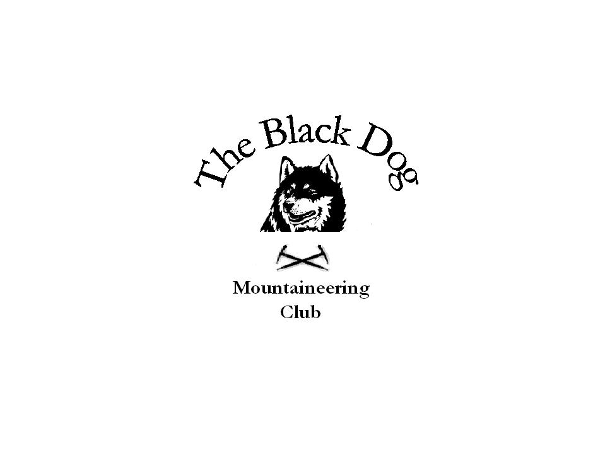
Black Dog Meet

No. 67 “Ben Vorlich”

Date 24th November 2007

In attendance
Charles Alexander Chris Barbour
Jo Barbour Dave Cameron
Dave Barbour Will Clark
Gerry Feeney Fiona O’Neill
Kirsty McLaren George Norman
Kenny Rae Andy Robb
Alan Sewell Colin Sidgwick
Steve Smart Tony Smith
John Stewart Graham Wyllie

Hills climbed

Ben Vorlich (984m) & Stuc a Chroin (975m)
Charles, Jo, Chris, Dave B, Will, Kirsty, George, Kenny, Andy, Colin & Tony
Meall na Fearna (809m) John
Meall an t-Seallaidh (852m) & Creag MacRanaich (809m)
Fiona & Steve
Ben Bhuidhe (not to summit) Gerry & Dave C
Meall na h-Aisre (862m) Alan & Graham

Weather

Very fresh NW wind with occasional showers (sleet/snow at higher level)

Report Notes

A near record attendance by club members on this meet surpassed only, I think, for John’s recent ‘Compleation’. Is this a good sign for 2008 and beyond?

The majority of us gathered at Ardvorlich on a fine but very windy morning. Light snow visible on the summits.
The main group (11) made an easy ascent of Vorlich by the good path directly up from the farm in less than 2hr. A very strong wind at higher levels made progress difficult at times, not helped by icy conditions underfoot in places. We stopped for lunch in shelter of rocks on descent to Bealach an Dubh Choirein before a steep snowy climb up the gully (well sheltered from the wind here) to South of main buttress to the plateau of Stuc a Chroin. Our return, to complete a good circuit, was via the ‘Butterfield’ route down to and along Glen Ample, narrowly avoiding getting mixed up in the late afternoon pheasant shoot, and thence to the hotel bar in St Fillans.

Meanwhile John, who had also set off from Ardvorlich at the same time, turned off at the path junction to head for the adjacent Corbett. He got to the summit at 12.00 noon and saw only 3 people walking along the corrie and 1 on summit of Vorlich (presumably he who had arrived with dog just after we had left).
Fiona and Steve also went after Corbetts and did Creag MacRanaich and
Meall an t-Seallaidh from Lochearnhead. Their weather was similarly very windy with snow showers. “Still good fun though.”

Graham and Alan headed north to Garva Bridge (River Spey) and went out in rain - which turned to snow higher up. Blustery showers on top gusting to gale force winds and white out conditions. “Other than that it was great.”

Gerry and Dave C set off to climb Beinn Bhuidhe from top of Loch Fine by cycling along Glen Fyne as far as permitted. They continued along Glen Fyne to Inverchorachan and took a wet, muddy path on south side of burn. Some scrambling was required parts of the path. Gerry ‘bailed out’ when they came to a section where a slip could result in a drop into the gorge below. Dave continued up into the corrie to about 800m he reckons and then turned back due to deteriorating weather and to be sure he was off the hill before it was dark. It was Dave's third attempt to get to the top it must have something against him.

Next Meet

Falls of Unich (Christmas meet). Saturday 8th December. Organiser is Gerry Feeney.

