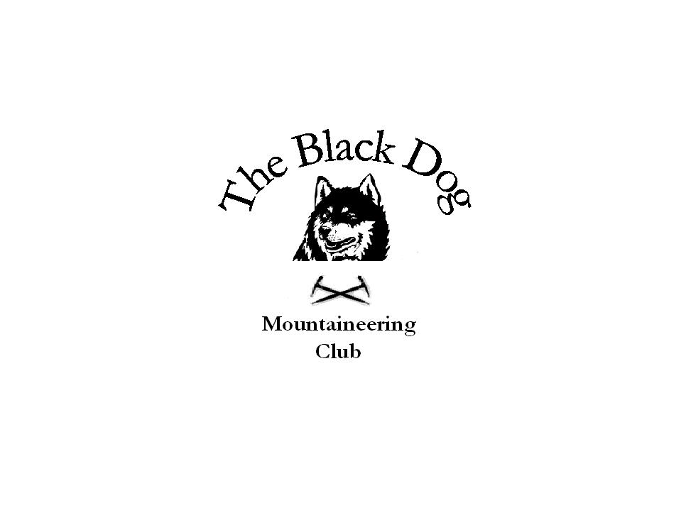Black Dog Meet

No. 68 “Christmas meet”

Date – Saturday 8th December 2007

In Attendance | Steve Davis, Pat Davis, Tony Smith, Lorna Smith, George Norman, Jimmy Mains, Andy Robb,, Steve Smart, Fiona O’Neil
Hills Climbed | A. Cairn Lick (Main Group)  B. Lochnagar (Steve and Fiona)
Weather | Fair then windy later with snow showers
Notes | A. The main group set out Glen Esk car park for a fine morning walk along shore of Loch Lee and on up the glen. Crossed river at bridge to join path to Falls of Unich (brief stop for photography and refreshment at the falls) and onward more steeply to Damff. Good amount of water in the stream combined with clear snowy conditions at higher levels made for fine scenery.  Lunch at the top of the glen then easily across frozen ground to Cairn Lick and Inchgrundle. Weather deteriorating by this stage with lower cloud and stronger winds for descent on track for return walk in the glen (snowing by now, 14.00). A very straightforward but pleasant circuit.  Thanks to Lorna for mince pies and hot chocolate etc. for all on return to Montrose  B. Steve and Fiona left the Glen Muick car park about 8:30 and made their way up the normal route by the Alt-na-giubhsaich burn. Fine and clear most of the way to below Meikle Pap then mist covered the tops. Not as much snow as expected but enough to give a wintry feel, along with a biting wind.  Returned by the Glas Allt to the loch and a refreshment stop before the trek back to the car. Some good sized old cornices round the corrie edge which had crumbled a bit.  Snow came on as we reached the loch side and continued on and off all the way back.
Next Meet | Glenshee (winter navigation) 26th and 27th January. Organiser Mike Mclaggan.

