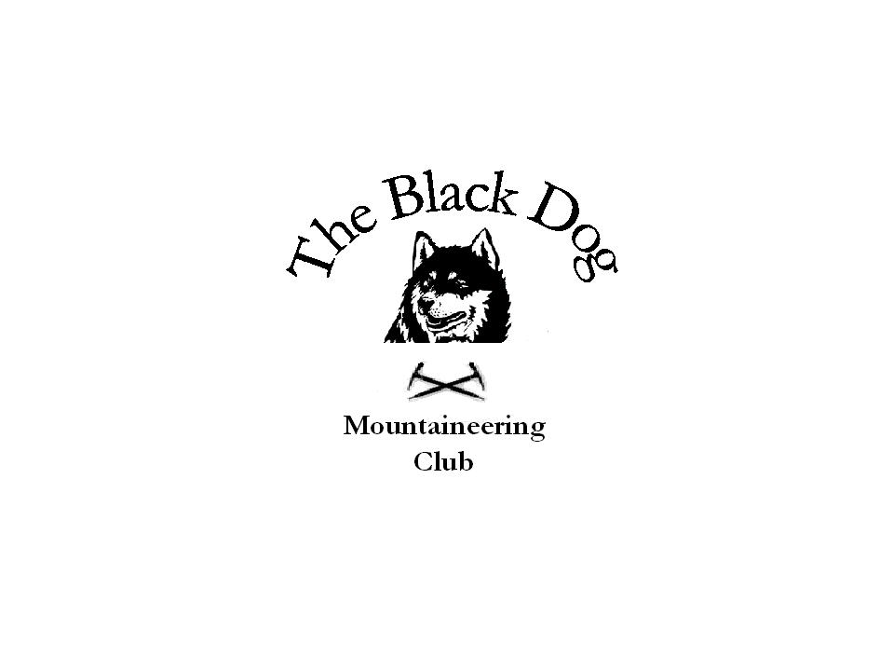Black Dog Meet

No. 69

Glenshee Winter Skills Weekend

Date - Saturday 26th – Sunday 27th Jan 2008

Hills Climbed | Saturday - Winter Skills , Navigation and Avalanche on Glas Maol (All)  Sunday – MRT Exercise on Glas Maol (Mike)  Carn a Gheoidh , The Cairnwell and Carn Asoda - George S , Ian , Dave  The Cairnwell and Carn Asoda – George N and Andy  Mt Blair and Duchary Hill – Alan , Val , Kirsty
In Attendance | Alan Sewell , Mike McLaggan , Kirsty Mclaren , George Skinner , George Norman , Val Inglis, Davie Cameron , Stewart Richardson , Graham Wyllie , Andy Robb, Ian Stuart
Notes | Good accommodation at a reasonable price at the Spittal bunkhouse £16 per night inc breakfast. Carvery was really good and as much as you could eat…..  Snow Conditions - reasonable cover but quite soft in Coire Fionn, at least we could put crampons on for Saturday. Softer on the Sunday.  Had a chance to look at skills again and did pacing work and some micro navigation. My group managed to head into the Coire for an avalanche session. Hopefully we can do more again next year.  Weather - a bit overcast but tops were clear with sunny spells and a few showers. Sunday was quite nice.  Never in my life heard so much snoring (what a nightmare for Kirsty, would put her off men for life !!)  Stewart’s navigation session in the bar on the Saturday night!! NOT  My Rutschblock test actually worked to everyone’s amazement….by the way there was a cornice collapse on Glas Maol overnight…  Everyone enjoyed the day and took something from the session. Thanks to Alan and Stewart for helping out.  Mike McLaggan 28-01-08
Next Meet | Crianlarich Sat 23rd Feb - Organiser Jimmy Mains

