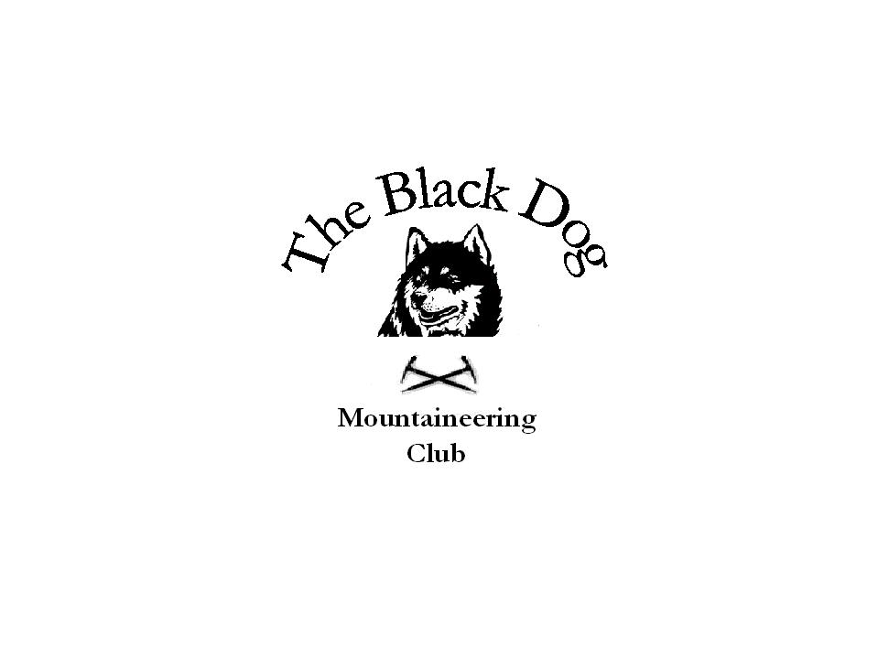Black Dog Meet

No. 70

Crianlarich

Date - Saturday 23rd February 2008

Hills Climbed | Mount Keen (939m)  Creagan na Beinne (888m)  East Cairn Hill (567m)  Mendick Hill (451m)  Meigle Hill (423m)  Sell Moor Hill (423m)
In Attendance | Alan Sewell, John Stewart, Andy Robb, Tony Smith
Notes | A ‘non-meet’ report this as nobody went out anywhere near Crianlarich but nevertheless a very windy day was had by all.  Alan and John climbed Creagan na Beinne near Loch Tay, a round including a couple of tops and/or a Graham was planned but curtailed due to the wind.  Andy climbed Mount Keen, for the “umpteenth” time, and had to hang on to the trig point to steady himself in the ‘breeze’.  Tony headed South (as recommended on Radio Scotland ‘Out of Doors’) to add, uneventfully, to his Marilyn tally in the Pentland and adjacent hills.  Gerry Feeney
Next Meet | Kinlochewe 29th and 30th March - Organiser Tony Smith

