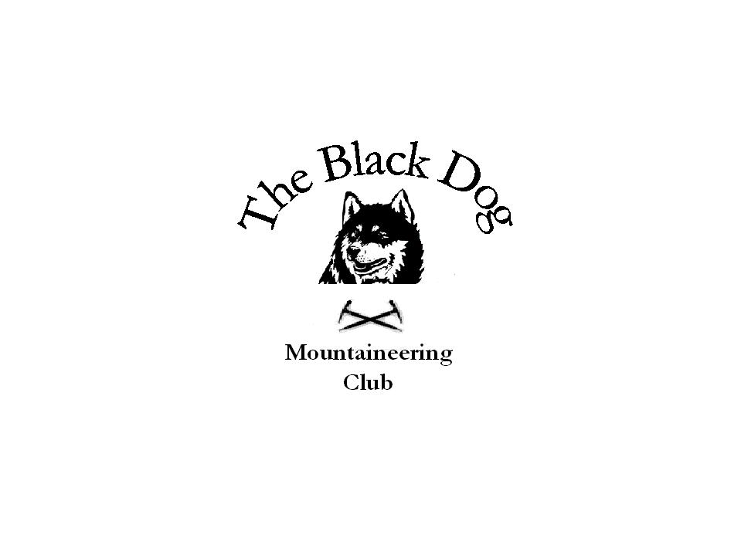Black Dog Meet

No. 71
“Kinlochewe”

Date - Friday 28th to Sunday 30th March 2008

Hills Climbed | A’Chailleach (997m)  Baosbheinn (875m)  Beinn an Eoin (855m)  Beinn Airigh Charr (791m)  Beinn a’Chaisteil (787m)  Little Wyvis (764m)  Meall a’Chaorainn (705m)  An Cabar (558m)
In Attendance | Charles Alexander, Dave Cameron, Pat Davis, Steve Davis, Val Inglis, Mike McClaggan, Kirsty McLaren, George Norman, Alan Sewell and Tony Smith
Notes | Friday  Despite poor weather forecast and a wet departure Charles, Alan and Tony set off early(ish) as planned, taking bikes for Beinn a’Chaistell. In the event we had a good ride in from the Black Bridge up Strath Vaich to Lubachlaggan. Some underfoot snow on the hill but straightforward ascent in quite reasonable conditions.  Pat and Steve took in the Graham Meall a’Chaorainn and seemed to be less fortunate with the weather  Saturday  Relatively clear conditions but a very strong wind and significant snow at higher levels.  Pat and Steve travelled to Poolewe for Beinn Airigh Charr.  Charles, Mike, Tony and Alan, again with bikes, tackled Baosbheinn and Beinn an Eoin. Rough cycling (over the handlebars, as by Alan, not recommended), a washed out bridge at the loch outlet and tough going in the wind made for a long day. Charles took the track back from the bothy whilst Mike, Alan and Tony made the second very steep ascent.  Dave, Val, Kirsty and George went round to the West Fannichs. The conditions also forced a change of plan here, to only one of the two Munros.  As an alternative day trip Gerry and Karel Burgoyne did Derry Cairngorm from Linn of Dee by cycling as far as Derry Lodge. Deep snow, on the track and the hill, was the only real difficulty.  Sunday  On the way home Mike and George took in Little Wyvis while Charles, Pat, Steve and Tony added An Cabar to the Marilyn tally. Alan, still suffering a cycling acrobatics ‘hangover’, enjoyed a snooze in the car. The Glasgow team left the second Fannich for another day and travelled directly home.  The Ledgowan bunkhouse renovations were not complete (contrary to the promise) so only one bathroom at present. The very restricted kitchen facilities will remain a serious drawback. The location is however very good, as are the hotel food and drink (no tuna bites this time though).
Next Meet | Galloway 18th to 20th April - Organiser Alan Sewell

