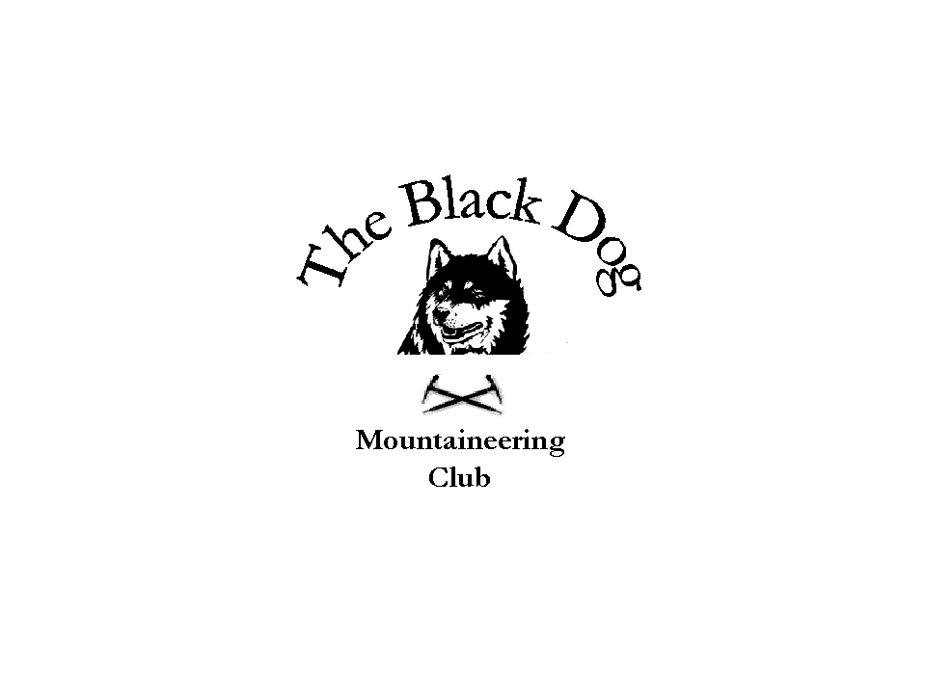

Black Dog Meet

No. 72 - Galloway

Date - Friday 18th-Sunday 20th April

Hills Climbed

Friday Corserine (814m) Alan & Gerry
Fell Hill (417m) Tony

Saturday The Merrick (843m), Shalloch on Minnoch (776m) Alan, Jenny, & Gerry
Mullwharchar (692m) and Craignaw (645m) Steve, Pat, Tony & Lorna {plus detour to Dungeon Hill (605m, a Donald) Tony}

Sunday Cairnsmore of Carsphairn (797m) Alan, Jenny & Gerry
Cairnharrow (456m) and Pibble Hill (383m) Steve & Pat
Cairn Pat (182m) and Bengray (366m) Tony & Lorna

In Attendance Alan Sewell, Gerry Feeney, Tony Smith, Lorna Smith
Steve Davis, Pat Davis, Jenny Davis

Weather

Friday Cold east wind, cloud around 2000ft.

Saturday Sunshine, strong cold east wind on summits.

Sunday Sunshine, strong cold east wind on summits.

Snow Conditions Only small patches, frost overnight.

Notes

Gerry & Alan left Montrose around 7.30am with the intention to do Corserine- leaving the pensioners to slumber on. Started the hill about 12pm from the east at Forrest Lodge - up and down in 4hrs. Arrived at the hostel about 4.30pm to find that SYHA only open their doors after 5pm! Expecting to be the only residents in the hostel in this quiet corner of the borders, we were surprised to find the hostel fully booked by the Ayr Cycling Club, with their support band “The Rusty Rims” - who played a full set on the Saturday night - (two guitar, amps, pa system, mics, the whole shooting match). The place was whipped up in to a near coma by the end of the night.
Tony slipped in a little Marilyn on the way down the road with Steve, Pat and Jenny arriving in time for dinner in the Cree Inn in Minnigaf. The highlight of the evening was Jenny turning up in a nuns outfit (very fetching! – if only the mother superior new she had sneaked out for the evening!)
Saturday was a bright morning with Alan, Gerry and Jenny setting off for The Merrick and Shalloch of Minnoch with a drive in between. The Merrick was a great little hill with excellent views, where as Shalloch on Minnoch was a wee Sh*t from the north, (deep heather and bog – not recommended). Worth noting are the contour lines on the map at this summit – remember, sometimes the trig point isn’t always the top.
The day was uneventful apart from losing Gerry 100yrds from the car on the way down (come on now it could happen to anyone!). On another “controversial” note a club member (who will remain nameless) was found to be wearing “performance enhancing” leggings - which once again rears its ugly head in the sport - during the ascent of these hills. The club cannot condone this behaviour and an investigation into the possibility of stripping the member of these “ticks” in the book should be considered!
The Mullwharchar (considered, incidentally, in the 60’s as a possible site for a nuclear waste repository) expedition was largely uneventful although the return tramp seemed to go on for ever! Fine views over to the adjacent Merrick. A good day.
On the way home on Sunday, Alan, Gerry and Jenny had a nice walk up Cairnsmore of Carsphairn, with Steve and Pat doing a couple of Marilyns - Cairnharrow and Pibble Hill before all meeting up at Abington Services and then home. Lorna and Tony also did a couple of easy Marilyns before heading South.

Thanks to all for a good weekend.

Next meet Skye –see Steve Smart

