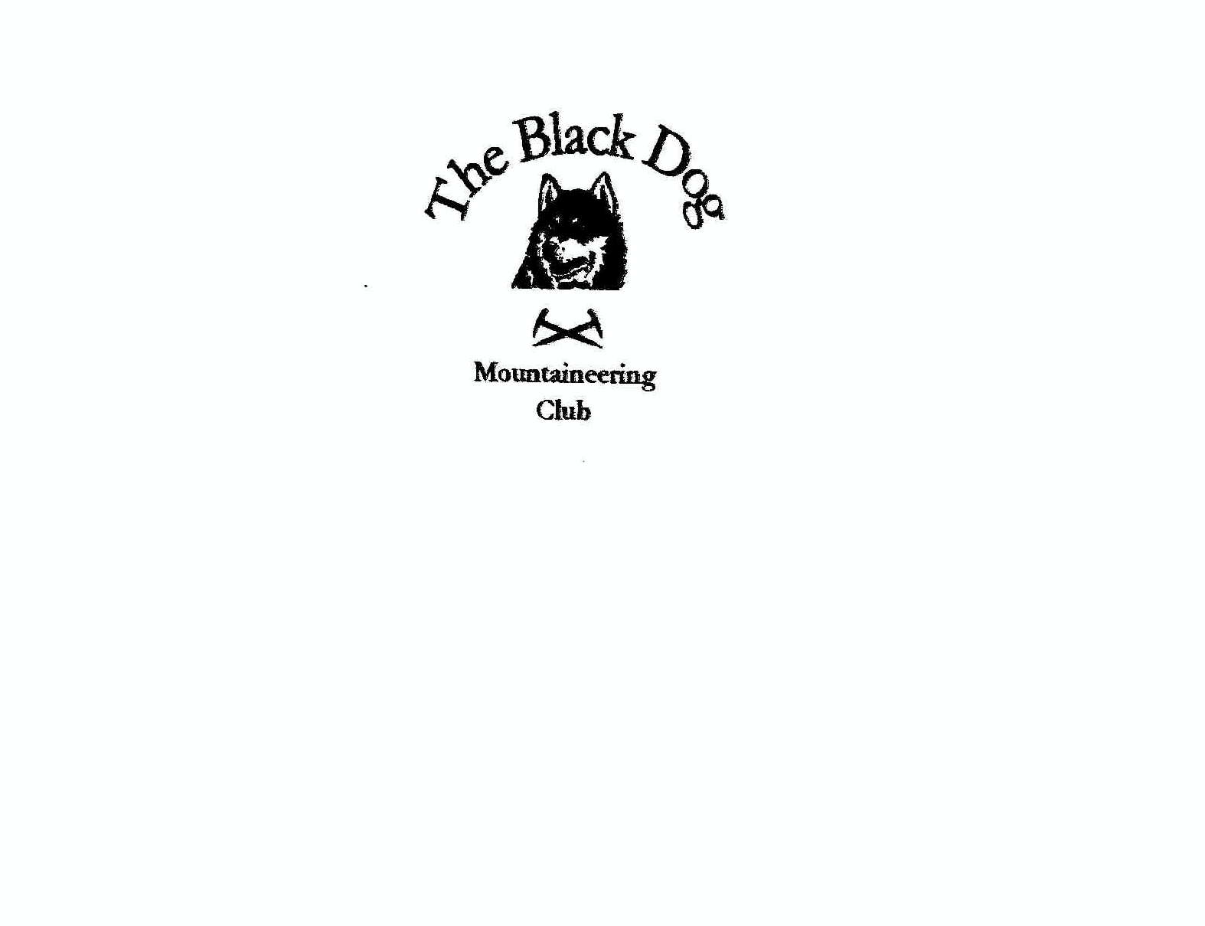Black Dog Meet
No.73-Skye.

Date- Friday 9th-Sunday 11th May-2008.

In Attendance Charles Alexander, Robin Clark, Wullie Clark, Gerry Feeney, Kirsty Mclaren, George Norman, Fiona O Neill, David Rowe, Alan Sewell, Elspeth Shanks, Russell Shanks, Colin Sidgwick, George Skinner, Steve Smart, Lorna Smith, Tony Smith, John Stewart, Andy Robb.
Hills Climbed

Friday Garbh-bheinn (806m) John.
Ben Aslak (610m) Charles, Lorna, Tony.
Beinn na Seamraig (561m) Tony.
The Inaccessible Pinnacle (986m) Gerry, George, David, Elspeth, Russell, Alan, Andy.

Saturday Roineval (439m), Beinn Bhreac (327m), Biod an Athair (313m)
Charles, Lorna, Tony.
Arnaval (369m) Charles, Tony.
Sgurr Sgumain (947m) Sgurr Alasdair (993m) Russell.
Sgurr a Mhadaidh (918m) George N, Fiona, Colin, George S, Steve.
Sgurr a Ghreadaidh (973m) Sgurr na Banachdich (965m) Fiona, George S, Steve.
Sgurr nan Gillean (965m) Kirsty, Robin, Wullie
Am Basteir (935m) Bruach na Frithe (958m) Gerry, Dave, Alan, Andy.
Glamaig (775m) John

Sunday Am Bathach (798m) Glen Shiel, John.
Sgurr Cos na Breachd-laoigh (835m) Loch Arkaig. Charles, Lorna, Tony.
Am Basteir , Bruach na Frithe. Fiona, Colin, George S, Steve.
Sgurr na Banachdich. Dave, Alan, Andy.

Weather

Friday Clear, then rain.

Saturday Thick mist, but warm. Inversion later.

Sunday Cloud broke to give blue skies and sun or was I dreaming.

The Tale Of The Weekend.

John climbed the superb corbett Garbh-bheinn on his journey to Carbost. Charles, Lorna & Tony climbed Ben Aslak over Kylerhea Glen, then Tony sprinted a couple of Ks over to Beinn na Seamraig to bag another marilyn.
Yet again The Inaccessible Pinnacle was made accessible as it was topped by 7 pairs of boots worn by Black Dog members ( Climbing lads Alan & Russell may have worn rock slippers….smoked pipe and read newspaper keeping warm in an old cardigan)
Everyone else made their way to The Old Inn by evening. We managed to get round a big table to make plans for Saturday but there seemed to be lots of empty tummy rumbling from the Pinn party, they arrived just after 9. I`m sure I saw the chef going out the back door when they came in.
Charles, Lorna & Tony were off for marilyns one of which sounds well worth a visit. Biod an Athair up by Dunvegan Head has the trig sitting on the top of the sea cliffs. Once back at the ranch Charles & Tony also did Arnaval just west of Carbost.
Russell set off on his own for Sgurr Dubh Mor but got so carried away scrambling he ended up on Sgurr Alasdair. (close enough!)
Kirsty, Robin & Wullie were bound for Sgurr nan Gillean. They were not far from the summit but the mist was so thick they decided to come back on a clear day to take in the views.
Alan, Andy, Dave & Gerry were in Coire a Bhastier for Bastier & Bruach. There was some gymnastics going on in the coire so it would seem, with the poor visibility everyone performed a 360.
Some of these lads doing a somersault I would like to see!!
Colin, Fiona, George N, George S & Steve headed into Coire a Ghreadaidh looking for the Sgurr Thuilm ridge, which at only 800m long is not easy to find!!! Once it was found we headed up the dreaded “ Banana Ridge” to Sgurr aMhadaidh.
After An Dorus Colin & George N left the ridge leaving the rest to carry on to Banachdich in time to have some views.
John & Elspeth wre going to climb Glamaig by Sligachan, but Elspeth had a change of mind and walked the 8 miles back to the Inn, probably the hardest walk of the day. Meanwhile John had set off to beat the time of the Gurkha who ran up the hill in 1899. His time was 55 minutes, we never found out if John beat him.
A big bonus for all on the ridge was a fantastic inversion.
After some food and cordial, everyone had a peaceful nights slumber.
Sunday had John off to Glen Shiel, and Am Bathach beside the Cluanie Inn. Charles, Lorna & Tony to Loch Arkaig for the Corbett, Sgurr Cos na Breachd-laoidh. (please read aloud in the company of others)
Alan, Andy & Dave were back on the ridge for Sgurr na Banachdich, the views must`ve been good.
Colin, Fiona, George S & Steve were in the gymnastics arena of Coire a Bhastier but opted to pass on the rotation for the traditional way up to Am Bastier then round to Bruach.
Robin & Wullie took the scenic route home with Wullie doing what all good mountaineers should do while driving, keep your eyes on the hills!
The others went up to Trotternish to survey The Old Man of Storr to finish off the weekend.
Big round of applause to” never give up” Gerry Feeney who topped the Inn Pinn.
I apologise for all the paper needed to print the report.( Send your claim to Chris Barbour)
Thanks to all who made it to the sunny isle.

Steve Smart.

Next meet June 27th-29th
Inchree. Gerry Feeney.

. .

