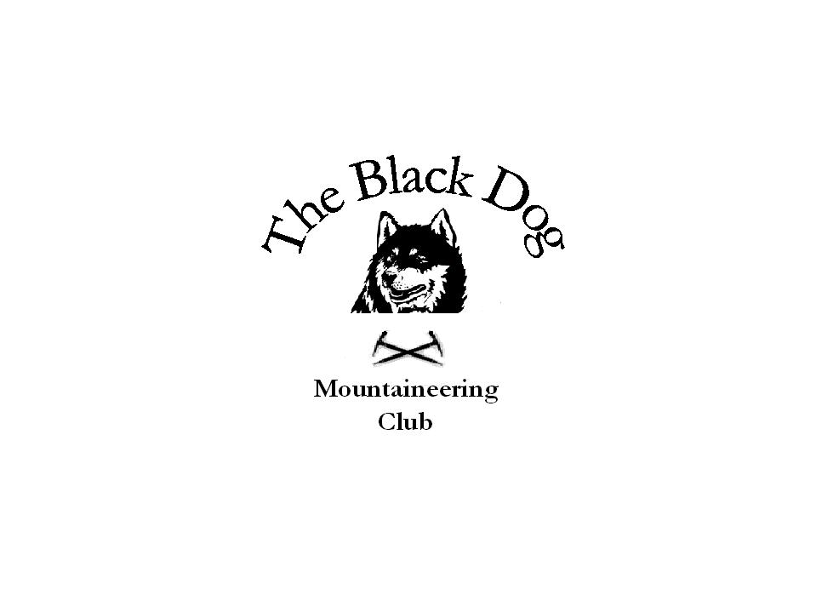Black Dog Meet

No. 75

Ullapool

Date - Friday 25th to Sunday 27th July 2008

Hills Climbed | Friday:  Am Faochagach (954m) Andy, Gerry, Dave, Jo, Ken and George  Carn Ban (845m) Tony, Alan, Kirsty and Charles  A’Chailleach (999m) Val and Dave  Saturday:  Beinn Dearg (1084m), Cona’ Mheall (978m) and Meall nan Ceapraichean (977m) Dave, Jo, Ken and George (and several million clegs and midges)  Ben More Assynt (998m) and Conival (987m) Val and Dave  Beinn Airigh Charr (791m) Tony, Alan and Charles  Sgurr Fiona (1060m), Sgurr Creag an Eich (1017m) and Bidein a’Glas Thuill (1062m) Gerry and Andy  Ben Wyvis (1046m) Kirsty  Sunday:  Meall Chuaich (951m) Andy and George  Meall Dubh (642m) Tony and Charles  Ben Kilbreack (961m) Val and Dave  Beinn a’ Bha’ach Ard (862m) Alan
In Attendance | Charles Alexander, Dave Barbour, Jo Barbour, Dave Cameron, Gerry Feeney, Val Inglis, Kirsty McLaren, George Norman, Ken Rae, Andy Robb, Alan Sewell and Tony Smith
Notes | 12 members attended this meet with glorious, if sometimes windy, weather for almost the whole time. Temperatures were in the mid twenties and only a shower of rain. Local carnivores in the forms of midgies and clegs were omnipresent.  Those are the bare facts, which make no mention of the long sweaty days spent achieving the goals.  The Am Faochagach group on Friday seem to have had an easy day with the dam being nearly empty. Ken Ray seemed very embarrassed about something, may have been about forgetting his sun cream. There was a suggestion that he could hire out his face as a red traffic light.  The Carn Ban group had a long hard day. The cycle in was so hard that one bike chain snapped near the start point for walking (16k from the car!). Hill was duly climbed and the chain put back together with a lot of muttering and a great team effort. The repair held all the way out, much to everyone’s relief.  Part of the group got the slowest fish and chips ever in the evening (1 hour wait) while the “Carn Bans” enjoyed an excellent meal with good service in the Ceilidh Place.  Of course, as is usual on these meets, there was some worry about getting any sleep as two of the members had fearsome reputations as stentorian snorers. They more or less lived up to their reputations with ear-plugs and thrown socks being used in defence.  Saturday was an epic day for the Ben Dearg and An Teallach groups, especially as dinner was booked for 8:30 with a non-refundable deposit if we were late! All were back in time.  There were some allusions to slight detours on one of the Saturday walks. No harm was done but precious time was lost. We should all be careful all the time that we are where we think we are, and not believe unquestioningly the other members of the group.  George and a German(?) lady were a bit embarrassed as he walked into the room he had had the previous night to be confronted by said lady. He had not been told of his change of room!  Good pints of Am Faochagach were enjoyed in the Argyll arms, which seems to be making a comeback. An excellent meal was had by all in the Ceilidh Place, before an early night by most.  As can be seen from the list, Sunday was treated almost as a rest day by most. Alan however took his bike up Glen StrathFarrar. This hill was hard work up the south ridge, with deep heather to start and then several false tops - along the way to the summit. He would recommend to anyone wanting to do this hill to follow the power station track around to Glen Neaty on the east side of the hill then make a direct approach from there.  Val and Dave will be much reduced when we next see them, lumps having been eaten out of them by the fierce natives. They carried on bagging till Thursday, with eight ticks on the list, no mention of how many on the bodies, for the week.  A good Black Dog weekend!!  The hostel is going over to B&B from the end of the year so enquiries will be needed for availability and price for next year.  Charles
Next Meet | Arran 29th to 31st August - Organiser Alan Sewell

