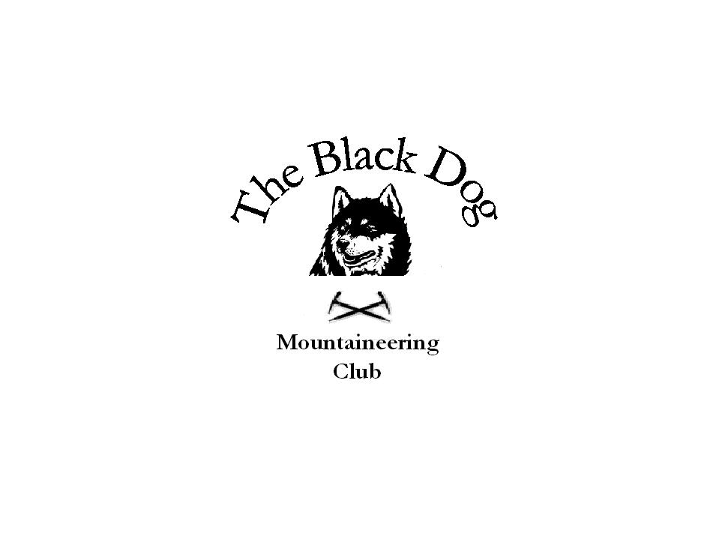Black Dog Meet

No. 77

Cairngorm

Date - Saturday 27th July 2008

In Attendance | Wull Clark, Gerry Feeney, George Norman, Fiona O’Neil, Andy Robb, Alan Sewell, Russell Shanks, Steve Smart, Lorna Smith, Tony Smith, John Stewart and David Ashby (guest)
Hills Climbed | Friday  - Sgurr na Feartaig (862m) Lorna and Tony  Saturday  - The Devil’s Point (1004m), Stob Coire an t-Saighdeir (1213m) and Cairn Toul (1291m) Gerry, George and Andy  - Eagle Ridge Beinn Ciochan (Lochnagar) Wull, Alan and Russell  - Cairn Gorm (1244m), Stob Coire an t-Sneachda (1176m) and Cairn Lochan (1215m) Lorna and Tony  - Geal-charn Mor (824m) Fiona and Steve  - Creag Mhor (895m) John and David  Sunday  - Carn nan Tri-tighearnan (614m) Tony
Notes | An unexpectedly good turnout of 12 (not including Val and Dave who were doing their own thing elsewhere).  The weather was not good with high winds early on the day and low cloud and rain later.  The Linn of Dee group took bikes to Luibeg but in the conditions decided two of the original three Munros planned was sufficient for the day.  The Lochnagar climbers started late and therefore finished the ascent at 19.30 (a club record?).  Geal-charn Mor allowed an early return home whilst Creag Mhor was wind, rain and mud – a great day.  John
Next Meet | Arrochar 17th –19th October - Organiser Steve Davis

