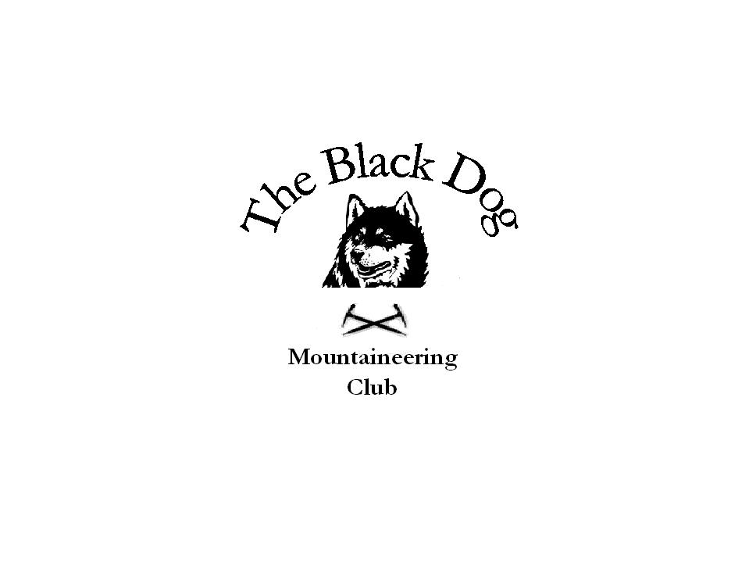

Black Dog Meet
No. 82 Aviemore

Date 21st March 2009.

In Attendance
Gerry Feeny
Kirsty McLaren
George Norman
Fiona O’Neil
Alan Sewell
Russell Shanks
Steve Smart

Hills Climbed

Friday
Alan & Russell | Coire an Lochain  -right branch Y gully II*
Coire an t-Sneachda
-crotched gully I/II
Saturday
Gerry, Kirsty and George | Bynack More | 1090m
Fiona and Steve | Creag Mhor | 895m
Alan and Russell | Kingussie Crag
 | -Classic Crack (Diff**)
 | -Tennis Shoe (V Diff**)
 | -The Slab/Edge (V Diff**)
 | -The Block Direct (Severe)
 | -Capped Corner (M Severe*)
 | -The Groove (H Severe**)
Weather Friday – Glorious Sunshine
Saturday – Dry start, then damp, then dry

Notes
Alan had an early start to this meet arriving in Aviemore on Wednesday to take part in a Glenmore lodge training exercise. Fine weather was enjoyed all week.

Russell arrived on the Friday to join Alan in some winter climbing, in shorts and t-shirt weather.
On the Saturday Fiona and Steve climbed Creag Mhor; Gerry, Kirsty and George climbed Bynack Mhor; and Alan and Russell climbed Kingussie Crag. The weather on Saturday started out promising with a certain member of the Bynack Mhor party uttering the words “it’s not going to rain today”. Needless to say 36 minutes later the rain started and only stopped once we’d descended a good way back down the hill. At least we could look back and see what we’d climbed after getting no view from the top. We were met at Allt na Feith Duibhe by Fiona and Steve. Alan and Russell faired slightly better with the weather as they were below the cloud base and managed to climb a mixture of routes in both winter boots and rock shoes – good practice for the Alps. A few half pints of real ale were enjoyed at the Bridge Inn, the rugby on the television was enjoyed less so due to Scotland loosing again. The upside of the rugby being on was the free haggis, neeps and tatties at half time.

The next meet is 17-19th April Kintail
Contact Dave Barbour

Kirsty McLaren

