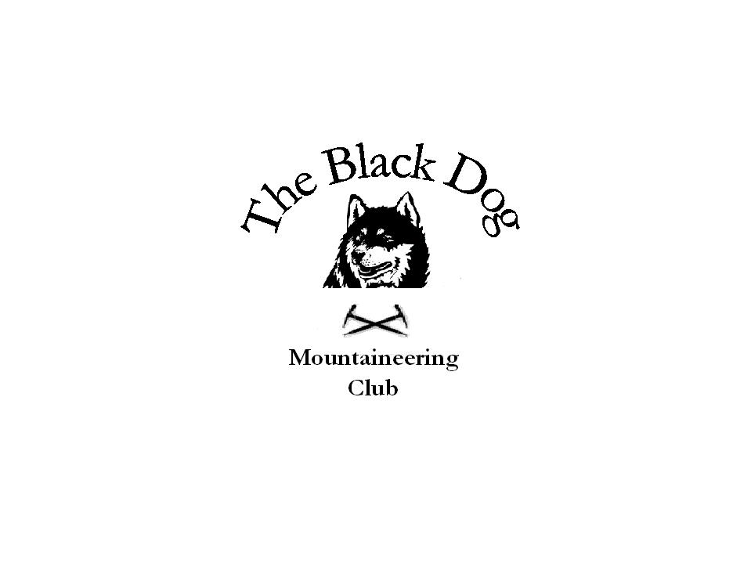

Black Dog Meet
No. 83 Ratagan

Date 17th-19th April 2009.

In Attendance
Charles Alexander, Chris Barbour, Dave Barbour, Dave Cameron, Jenny Davis, Pat Davis, Steve Davis, Gerry Feeney, Val Inglis, Liz K (guest), Kirsty McLaren, George Norman, Ken Rae, Andy Robb, Alan Sewell, Russell Shanks, Tony Smith

Hills Climbed

Friday
Alan, Russell & Kirsty | Sgurr a’Chaorachain – Cioch nose (V.Diff***) | 792m
Chris, Dave B, Dave C, Gerry, Val, George, Ken, Andy | The Saddle | 1010m
Chris, Gerry & George | Sgurr na Sgine | 946m
Charles, Tony, Pat & Steve | Beinn Dronaig | 797m
Saturday
Chris, Dave B, Ken & Andy | Saileag  Sgurr a’Bhealaich Dheirg  Aonach Mheadhoin | 956m  1036m  1001m
Chris | Ciste Dhubh | 979m
Alan and Russell | Coira a Ghrunnda –  White Slab (V. Diff**)
Gerry, George | The Five Sisters of Kintail  Sgurr na Ciste Duibhe  Sgurr na Carnach  Sgurr Fhuaran | 1027m  1002m  1067m
Charles & Tony | Aonach Buidhe  Faochaig | 899m  868m
Steve & Pat | Glas Bheinn | 394m
Dave C, Val, Liz, Kirsty, Jenny and Harry(dog) | Beinn Fhada  A’Ghlas Bheinn | 1032m  918m
John Stewart and grandson | Borneo – Mount Kinabalu rest house | 3200m
Sunday
Val, Liz | The Five Sisters of Kintail  Sgurr na Ciste Duibhe  Sgurr na Carnach  Sgurr Fhuaran | 1027m  1002m  1067m
Dave C | A’ Chralaig  Mullach Fraoch-choire | 1120m  1102m
Alan & Russell | Glen Nevis –  Pandora (Severe*)  Three pine wall (M Severe*)  Pinnacle Ridge (Severe**)
Charles & Tony | Glas Bheinn | 394m
Steve, Pat & Jenny | Beinn a’Chaoinich | 410m
John Stewart and grandson | Borneo – Mount Kinabalu summit | 4095m

Weather What can I say – Glorious Sunshine all weekend

Notes

Alan Sewell’s report –

Russell, Kirsty and I left Fettercairn at 5.30am and headed for Sgurr a'Chaorachain in Applecross. The weather got steadily better as we got further west, where we broke into glorious sunshine about Loch Carron. We headed up the glen following the Russel burn to climb the classic Tom Patey and Chris Bonnigton route Cioch Nose - " the diff to end all diffs" a term used by the first ascensionists, now graded V. Diff***. Two other parties were on the climb but didn't cause us any issues. The climb was fantastic with the 3rd pitch being "right out there" on the edge of the yawning abyss. For her first ( and probably last?) outing on rock Kirsty did remarkably well although Elvis did make an appearance at one point - "thank you very much".
On Saturday Russell and I headed for Skye initially to climb Integrity, but the walk into Coire Lagan showed that the slab was still seeping water and therefore a quick exit to Coira a Ghrunnda was made to bask in glorious sunshine on White Slab (V Diff **).
On Sunday Russell, Kirsty and I headed for Glen Nevis where we climbed Pandora (Severe*), Three pine wall (M Severe*) and Pinnacle Ridge (Severe**), while Kirsty sunbathed.
For the whole weekend we must have climbed about 15 pitches of V. DIff to Severe rock - a fantastic weekend.

Tony Smith’s report –

Friday.
We all did Beinn Dronaig (797m) a remote Corbett reached by a tough cycle ride (head wind and rough terrain) in from Attadale to Bendronaig Lodge (a very fine open estate bothy).

Saturday.
Steve and Pat did Glas Bheinn (394m) a very fine viewpoint just above Glenelg ferry terminal.

Charles and Tony did Aonach Buidhe (899m) and Faochaig (868m) two further remote Corbetts at the head of Glen Elchaig again reached by bike.

Sunday
Steve, Pat and Jenny did Beinn a'Chaoinich (410m) a Marilyn above the Glenelg road.

Charles and Tony did Glas Bheinn (394m).

Val Inglis’ report –

Thanks for a great weekend. I'm so happy to have been with such a good bunch of people and totally inspired that at less than 6 months post surgery I managed 6 Munros. Brilliant! Thanks again to Chris for all his help on the ridge and with transport.
Hills climbed:
Friday - Val & Dave - The Saddle or The Whoorin' Ridge!!!
Saturday - Val & Dave (& Liz) - Beinn Fhada & A' Ghlas-bheinn
Sunday - Val (& Liz) - The 5 Sisters via Sgurr nan Spainteach - Munros were Sgurr na Ciste Duibhe, Sgurr na Carnach & Sgurr Fhuaran. Our bridge over the river on the way back was totally out so we had to wade over - very refreshing!!!!
Dave - A' Chralaig & Mullach Fraoch-choire.
Look forward to the next time.

Dave Cameron’s report –
Friday: The Forcan Ridge, ( The Saddle) as you know because you were there! Great day, good group effort and I thought everybody had a good laugh doing it.

Saturday: Ben Attow (Beinn Fhada) and A' Ghlas Bheinn. What a gruelling day, the guide books do not give any hint to what you are up against. It seems they have left you to discover the place for yourself (not recommended in bad conditions). The route from the books are questionable. Also many thanks to Harry McKnab (black dog, dog) for sharing his water. Courtesy of Jenny Davis.

Sunday: A' Chralaig and Mulloch Fraoch Choire. What a ridge to the second munro stunning and fun at the same time.

Great Sunday and a fine end to a spectacular week end.

John Stewart’s report –

I had a climb in Borneo a wee bit away from Kintail

Saturday 18th Climbed up Mount Kinabalu to a rest house at 3200 m altitude arriving about 6 pm

Sunday 19th Climbed to the summit at 4095 m (13450 ft) leaving about 2.40 am and reaching the summit around 6 am Great weather with a temperature of 5 C

I took a photo of black dog t-shirt at top with son-in-law and grandson and also a photo of the three before the start

On behalf of the rest –

Well done to John Stewart for coordinating your trip to coincide with a blackdog meet. A great achievement in climbing Mount Kinabalu.

A brilliant weekend had by all. A great turnout with a huge variety of hills climbed and we couldn’t have asked for better weather. I particularly enjoyed the camaraderie going over the Forcan Ridge. Well done to everyone and a special mention to those who were making their comebacks from injuries. Good accommodation at Ratagan SYH and fine meals at Kintail Lodge Hotel.

Cheers.

Dave B.

Next Meet is Skye 8th-10th May - Steve Smart

