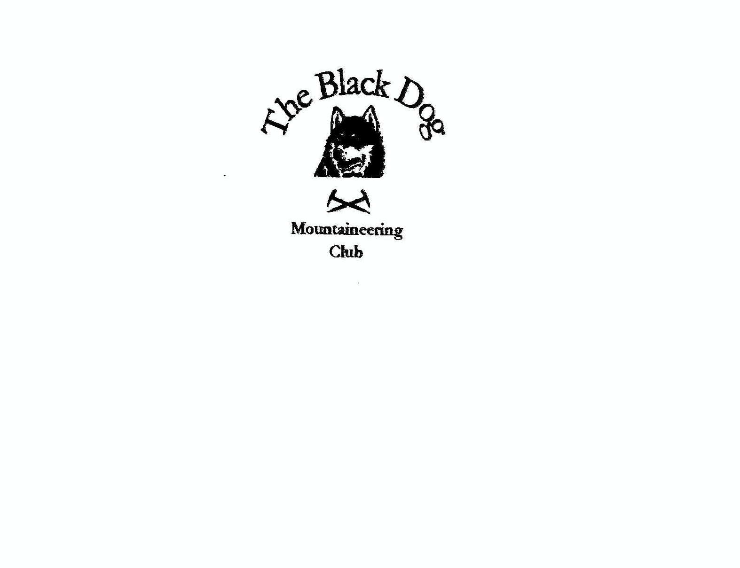

Black Dog Meet

No. 84

Skye.

Date-Friday 8th-Sunday 10th May 2009.

In Attendance Charles Alexander Davie Cameron
Robin Clark Wull Clark
Gerry Feeney Richard Marwood
David Mckay Kirsty Mclaren
George Norman Fiona O Neill
David Rowe Alan Sewell
Elspeth Shanks Russell Shanks
Colin Sidgwick George Skinner
Steve Smart Barry Smith
Lorna Smith Tony Smith
Graham Wyllie Lindsay Wyllie

Mountains Climbed

Friday Lorna & Tony Ben Geary 284m, Beinn Chreagach 328m
Barry & Davie C
Tony, Barry Ben Meabost 346m
& Davie C
Elspeth & Russell Meall na Suiranach 543m
Alan, Kirsty &
Dave R Sgurr Alsadair 993m

Saturday
Tony & Lorna Meall na Suiranach 543m,
Bioda Buidhe 466m
Tony Beinn Bhreac 448m
Biod Mor 383m
Gerry & Davie C Sgurr Alasdair 993

Robin, George N
Charles, Barry, Wull
& Russell. Sgurr nan Eag 924m

Alan, Kirsty &
Dave R Sgurr a` Ghreadaidh 973m

Fiona & Steve Sgurr Eader da Choire 807m
Sgurr a` Ghreadaidh 973m
Sgurr na Banachdich 965m
Sgurr Dearg 978m

Lindsay & Graham Mcleods Maidens ( not climbed, don`t
know what went on
with the “Maidens”)

Sunday Tony & Barry Sgurr nan Gillean 965m

Russell & Alan Cioch Slab Corner (Diff)
Walwarts (V Diff) Sron na Ciche

Graham & Davie C Cioch & Eastern Gully

Colin, George S
& Richard Sgurr nan Eag 924m

Fiona & Steve Sgurr an Fheadain ( The Spur 688m)
Druim nan Ramh W Top 847m)

Weather Friday- Sunny with showers.
Saturday- Low cloud & snow showers.
Sunday- Sunshine***

Notes

Friday arrivals on Skye were out and about, Alan, Kirsty & Dave R took a saunter up the moving staircase of the stone shoot to visit Alasdair.
Tonys squad of Lorna, Barry & Davie C were on a hit and run mission at opposite ends of the island, Ben Geary & Chreagach in the north and Meabost in the south were knocked off. Elspeth & Russell took in Meall na Suiranach atop The Quraing.
Saturday saw 8 groups set off in different directions, it was like an operation to take over Skye. Tony bagged another clutch of “mountains”!! (with Lorna along for 2).
Davie C & Gerry after hearing that the stone chute was pleasant went for that , George S & Colin took the easy tourist route to near the summit of Gillean the snow in every hand & foothold being a problem.
Alan, Kirsty, Dave R, Steve & Fiona left from the YH for Coire a Ghreadaidh where they split, Fiona & Steve going up the crumbling Sgurr Eader da Choire ridge to the main ridge which was followed to Sgurr Dearg.
Alan took his team on a first winter ascent of Eag Dubh, (the first winter ascent in May that is), Slightly larger width people may have a problem, it is quite narrow.
Accurate navigation is needed to find the start of the route, so well done Alan!!!
A large party headed further south to Sgurr nan Eag then on to Sgurr Dubh,
Russell, George N, Charles, Barry, Wull & Robin did well to find Dubh under the conditions, but it was the snowy footholds which again were a problem especially in descent, so near. Lindsay & Graham went for the scenic approach, and the walk out to Mcleods Maidens.
At least everyone had a day in the mountains and were back safely.
The staff at the Inn did fantastic to get 22 hungry folk seated in a small room, then churn out the pre-ordered food along with the nearly forgotten wine. A few soft drinks were then demolished before lights out. Or was it few soft drinks?
Sunday, and the weather looked promising, the snow remained a problem, but at least the sun shone.
6 Set off for Gillean, with only Tony and Barry reaching the summit for Barry`s 100th Munro, a brilliant mountain for the milestone, easily remembered.
Colin, Richard & George S took the long trek to Sgurr nan Eag, the change in overhead conditions giving them a good day out and another Munro underfoot (and hands).
Alan & Russell had their” jangly bits” out for a couple of routes on Sron na Ciche,
Cioch Slab Corner (Diff)& Walwarts (V Diff).
Graham & Davie C were also in Cioch Slab area topping The Cioch. Wull headed into Coire Lagan but had to retire after feeling a bit woozy, having received a kick on the head from Robin on Saturday. (What were they up to?)
Fiona & Steve headed for a scrambly route on Sgurr an Fheadain (The Spur) past The Fairy Pools. If you haven`t seen them, I highly recommend a visit.
After Fheadain it was on to the west top of Bidien Druim nan Ramh then into the coire and out.
Sorry if I`ve missed anything out and for the delay, but its quite a bit for a one fingered typer to get through. Thanks to Lorna & Tony for sorting out the food orders.
Next meet 26th-28th June 2009 Torridon. Meet organiser, Val Inglis.

