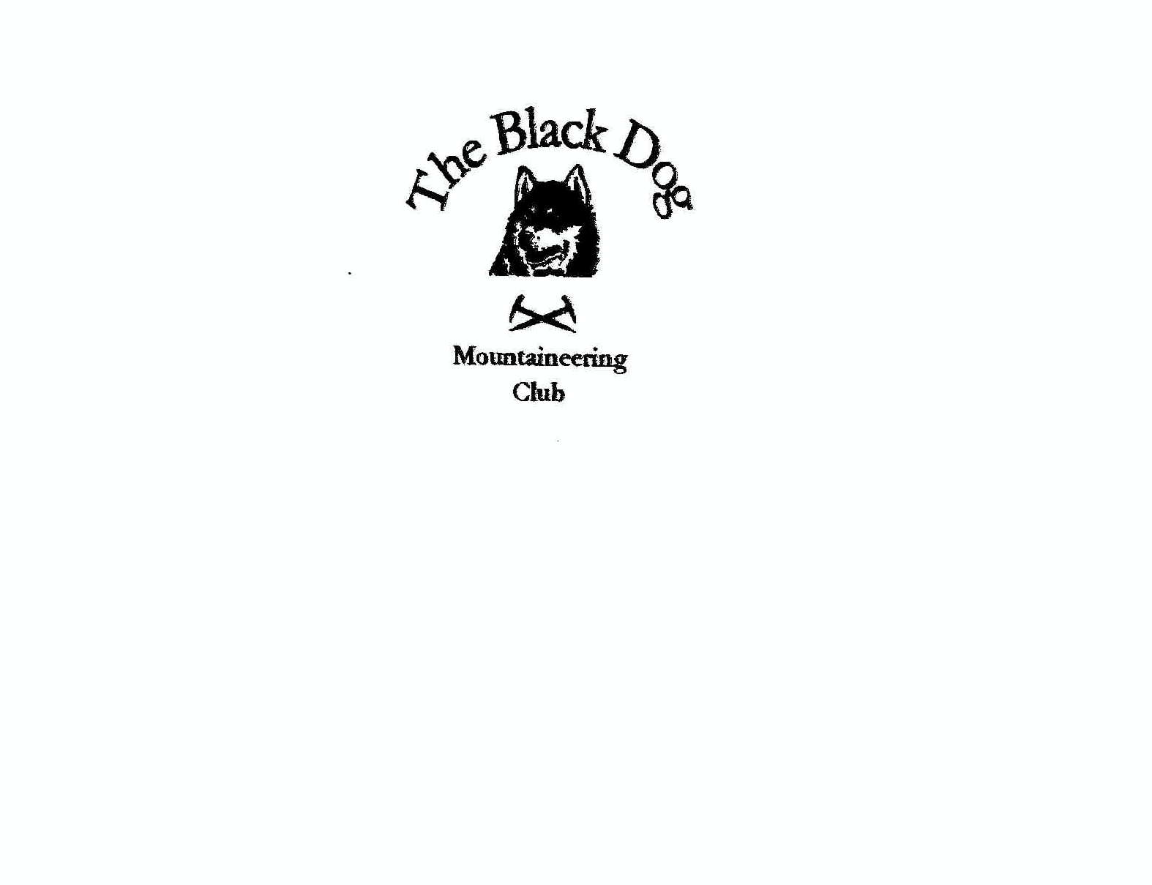

Black Dog Meet

No. 85

Gairloch (Torridon)

Friday 26th - Sunday 28th June 2009.

In Attendance Charles Alexander David Cameron
Jenny Davis Pat Davis
Steve Davis Gerry Feeney
Val Inglis Liz Kennedy
Kirsty McLaren John Meechan (guest)
Reg Popham (guest) Andy Robb
Alan Sewell Russell Shanks
Tony Smith David Traynor (guest)
Lindsay Wyllie

Mountains Climbed

Thursday Tony, Charles & Reg Sgorr nan Lochan Uaine (873m)
Sgurr Dubh (782m)

Friday Tony, Charles, Reg, Beinn Dearg (914m)
Lindsay & (hag)Gus

Val, David, Kirsty Liathach
& Andy - Spidean a’ Choire Leith (1055m)
- Mullach an Rathain (1023)

Steve & Pat Beinn a Chearcaill (725m)

Alan & Russell Ruadh-stac Mor (1010m) via the central
buttress (Hamilton’s route Severe ** 4a)

Saturday Tony, Charles, Reg Meall Mheinnidh (722m)
& Alan Beinn Lair (860m)

Val, David, Kirsty, Beinn Eighe
Andy, Gerry, Jenny - Ruadh-Stac Mor (1010m)
Russell, John, Liz, - Spidean Coire nan Clach (993m)
Dave T, Lindsay & Gus

Steve & Pat Meall Lochan a’ Chleirich (403m)
An Cuaidh (296m)

Sunday Tony, Charles, Reg, Bidein Clann Raonaild (446m)
Steve, Pat & Jenny

Val, Dave & Liz Slioch (981m)

Gerry, Kirsty & Andy Beinn Alligin
- Tom na Gruagaich (922m)
- Sgurr Mhor (986m)

Alan & Russell Raven’s Crag (Gairloch Crags)
- Lucy V Diff**
- Charelstone Severe** 4a
- Entasis V Diff* (4c variation finish)

Weather

Spectacular – sunny, dry, hot…very hot, almost cloud-free with the exception of Saturday morning when there was quite a lot of low dark cloud covering the higher summits, but this miraculously disappeared by lunch time. Splendid conditions. Much Blackdog sweat was lost in the hills over the weekend.

Notes / Highlights

Thursday
Tony, Charles and Reg started the weekend early, drove over on Thursday morning and made a dent into Tony’s last few remaining Corbetts.

Friday
Tony, Charles & Reg were joined by Lindsay and Gus the dog (full name Haggis) to climb Beinn Dearg.
Steve and Pat enjoyed a beautiful day on their chosen hill, preceded by the obligatory bacon butties!!!! – not that I’m firing you in or anything! Glad the ankle continues to improve!
Russell and Alan left Aviemore at 6.00 am with the intention of canoeing across Loch Maree to climb Wisdom Buttress on Beinn Lair. However, when they arrived at the loch the wind was whipping the waves up on the middle of the loch. They made a hasty retreat and decided to go and climb on the triple buttress of Ben Eighe instead. They ended up climbing Hamilton’s Route Severe** 4a on central buttress – an excellent route with a bold delicate crux at the final tower (you can tell I didn’t compose this part myself.) 10 pitches of excellent climbing were finished at 6.00 pm where they decided to take in the summit and a couple of tops before descending to the glen.
Val, David, Kirsty and Andy all met up at the start of Liathach and set off to boldly go where no man had gone before – at least that’s how it felt looking up at that truly monstrous mountain. The ridge was awesome, and the odd words of encouragement were most welcome. It was a bit odd to look down and see the cars parked 3000 feet beneath your feet! It was also odd to experience Andy yawning his way over the ridge. Clearly he needs a greater buzz……Aonach Eagach blindfolded!!! He assured us it was his body’s way of dealing with stress! Whatever!! We lay in the sun at the top of Mullach an Rathain and soaked up the spectacular views before the steep scree descent back to the road.
We all arrived at Gairloch youth hostel at various times throughout the afternoon and evening, some opting to eat out and others eating in with enough food for an army - once we finally managed to gain access to the kitchen! The hostel in Gairloch was in a wonderful setting by the sea, but was a bit cramped in terms of kitchen space and the shortage of showers was woeful.

Saturday
Tony, Charles, Reg and Alan set off with 2 canoes (thanks to Alan and Reg) and canoed across Loch Maree to the start of their hills – a great alternative to the 20 odd mile walk from Poolewe! The trip back was a bit choppy but a cunning plan by Reg to strap the 2 canoes together (the first ever Blackdog catamaran) proved to be the best call of the day. They all got a bit wet by all accounts, but didn’t require to share Alan’s water-wings, and all returned to shore safe and well.
Steve and Pat went their own way and enjoyed some peace and quiet.
The rest of us set off for Beinn Eighe. The original plan to do the whole ridge was quite quickly out-voted, largely due to time restraints. With only 2 showers to cleanse the whole hostel of its blood, sweat and tears, we decided that an earlier return to base camp would be advantageous. Russell decided to return with us to Beinn Eighe to take in the second peak which he quite frankly couldn’t be bothered to do yesterday. Anybody would think they’d done a 10 pitch climb or something. (Just having a merry jape ☺). Gerry set a formidable pace (all thanks to his spinning classes and a woman named Susan!!!) and we were soon looking up at the triple buttress where the boys had been climbing the day before – most impressive! We hit the first Munro in thick mist, but as we walked along the ridge the skies cleared and the views were spectacular. I think the sheer enormity of Beinn Eighe struck us all. The descent, once again, was steep scree but it didn’t pose too much of a problem. More problematic were the swarms of clegs which attacked with venom as soon as we hit the road side. They are postitively EVIL! And prefer female flesh to male!
The afternoon got hotter and a last minute decision to go for a pint to cool off in the blistering heat was a great call.
I had picked up some bottles of fizz which I managed to get well chilled and once we’d all got showered we got together and had a wee aperitif before heading off for dinner. Thanks to David C for the slab of Braddon Rost which we all got stuck into like vultures round carrion.
Dinner at The Old Inn had been pre-ordered which took away a lot of the hard work and we all ate like kings. The use of the local taxi firm meant nobody had to drive, but the delay in the relay system was a bit of a pain.

Sunday
We all went our separate ways but I think I can speak for us all when I say we suffered from the heat during the morning. I for one was grateful when the clouds covered the sun at lunch time and gave us a bit of respite. David, Liz and I did Slioch which was another monster hill. Kirsty, Andy and Gerry conquered Beinn Alligin, Alan and Russell climbed Lucy et al, and the others met at the top of Bidein Clann Raonaild having started from different sides. Another successful day in the hills.

Conclusion

A wonderful weekend!! Well done to Tony for ticking off 4 of his remaining 5 Corbetts. His joint compleation with Steve, set for August 22nd is a go Go GO!! Put it in your diaries!
Thanks to everyone for coming and well done!

Next Meet – Inchree, 17th – 19th June, organiser Steve Davis.

P.S. Alan, sorry I stood on your leg!

