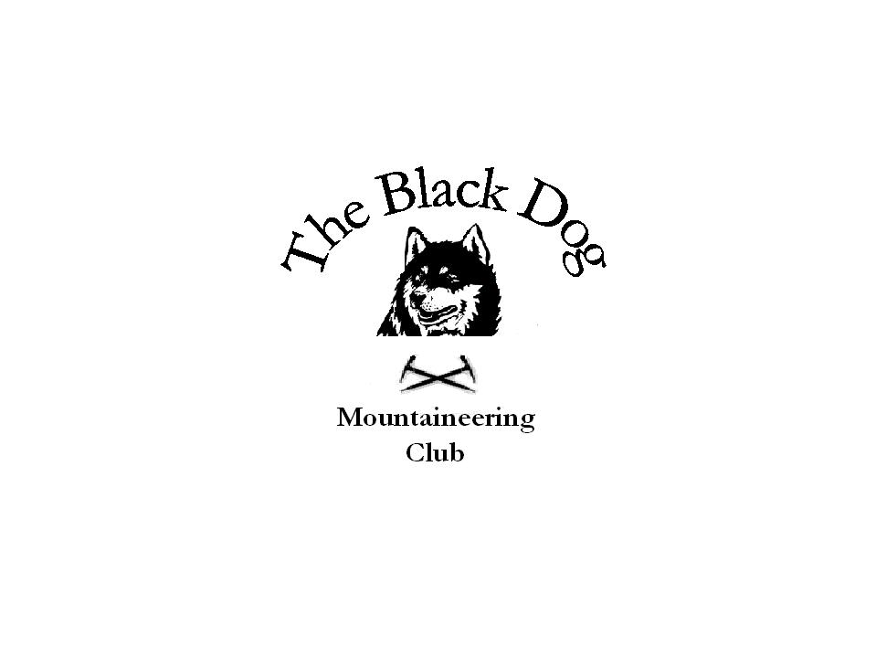
Black Dog Meet

No. 93 Bridge of Orchy

Date 26th to 28th February 2010

In Attendance | David Cameron
 | Robin Clark
 | Wull Clark
 | Gerry Feeney
 | Val Inglis
 | Kirsty McLaren
 | Fiona O’Neil
 | Russell Shanks
Steve Smart
Jon Pickering (guest)

Hills Climbed

Friday | Robin and Wull | Ben Inverveigh | 639m
Saturday | David, Robin, Wull, Gerry, Val, Kirsty, Russell, Jon | Ben Challum | 1025m
 | Fiona and Steve | Stob Ghabhar | 1087m
Sunday | Gerry, Kirsty, Russell, Jon. | Beinn an Dothaidh | 1004m
Weather Sunshine with any cloud above most tops. Cold, with gusting wind making it feel colder. Severe avalanche risk with fresh snow underfoot.

Notes
Initial attendees for this meet numbered 15, however by Friday night this had dropped to 10 with excuses reasons including sore backs, possible pneumonia and ‘my mum won’t let us come’. I’m sure the weather report and severe avalanche risk had nothing to do with the decisions.

Robin and Wull kicked off the weekend with a walk up Ben Inverveigh.
On the Saturday Fiona and Steve climbed Stob Ghabhar and David, Robin, Wull, Gerry, Val, Kirsty, Russell, Jon climbed Ben Challum. Gerry set off at a fair old pace and talk was about how the spinning classes were paying dividends in Gerry’s fitness. As it transpires Gerry was trying to catch up with another group in front who he though was the Black Dog group. The first part of the walk was difficult in places due to the fresh snow but the lead was swapped at regular intervals, with Val clearing the path through the most difficult terrain. About 15 minutes from the top of the hill we met two guys coming down the hill. When asked how the conditions were on top they mentioned that one of them had set off an avalanche about 100m wide. On looking at the piece of ground in question, and seeing the cracks still forming before our eyes, the decision was made not to make the trip to the top and leave it for another day. Different techniques were employed descending the hill with Robin favouring the bum slide using ice axe as paddle and Russell favouring the face plant and earning himself an injured eye. Fiona and Steve faired slightly better making it to the top of Stob Ghabhar.

On the Sunday Gerry, Kirsty, Jon and Russel climbed Beinn an Dothaidh, determined to get Jon up his first Munro. On this occasion we were successful.

Gerry, Kirsty, Jon, Robin, Russel and Wull stayed both Fri and Sat night in the bunk house which was good but unfortunately lacked kitchen facilities. Luckily the hotel next door provided full meals. Russell did have to resort to spreading the butter on his sandwiches with his credit card.

Next meet 27th March, Trossachs
Contact Dave Barbour

Kirsty McLaren

