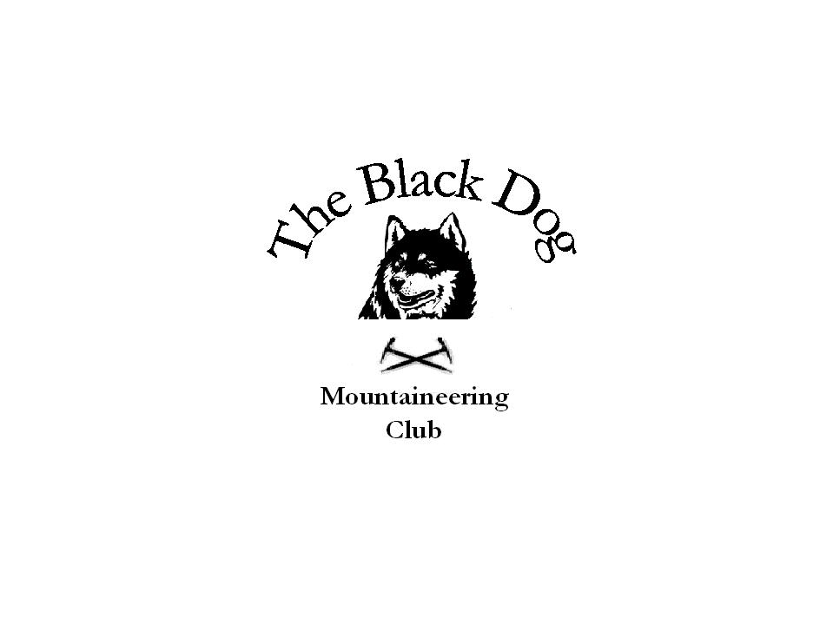Black Dog Meet

No. 94 “The Trossachs”

Date - Saturday 27th Mar 2010

Hills Climbed | Ben Vorlich (Loch Lomond) (943m) - Chris, Dave B, Ken, Val, Dave C, Jerry, Andy  Beinn a’Choin (770m) - Alan Sewell  Meall an Fhudair (764m) & Beinn Damhain (684m) - Steve S, Fiona
In Attendance | Chris Barbour, Dave Barbour, Gerry Feeney, Val Inglis, Davie Cameron, Andy Robb, Ken Rae, Alan Sewell, Steve Smart and Fiona O’Neil.
Notes | The Munro group headed off up the road towards the dam. We climbed up to the bealach then onto the first top then the Munro. A decision was made to head back along the ridge to give a different route off. The weather was blustery, wintry showers on top. We all got soaked coming off the ridge. We headed to the Drovers Inn at Inverarnan for a bowl of soup and a pint before heading home.  From Alan - Got to Stronachlacher at Loch Katrine at around 9.30am. Cycled up passed the head of the Loch - up Glen Gyle, where I dumped the bike and headed west straight for the summit of Beinn a’Choin. Weather was sunny with some blustery showers - snow showers above 700m. Views all around but the higher hills were in cloud most of the day. On arriving back at the bike I did contemplate doing Meall Mor (Graham) on the other side of the glen but another shower sent me packing. Back at the car by 1.00pm.  From Steve - Fiona and I did Corbett Meall an Fhudair, and Graham Beinn Damhain just to the north of Ben Vorlich on Saturday. We just missed you. You went past on the way home as we were at the car.
Next Meet | Kintail (Morvich) 16th – 18th April - Organiser Charles Alexander

Cheers.

Dave B.

