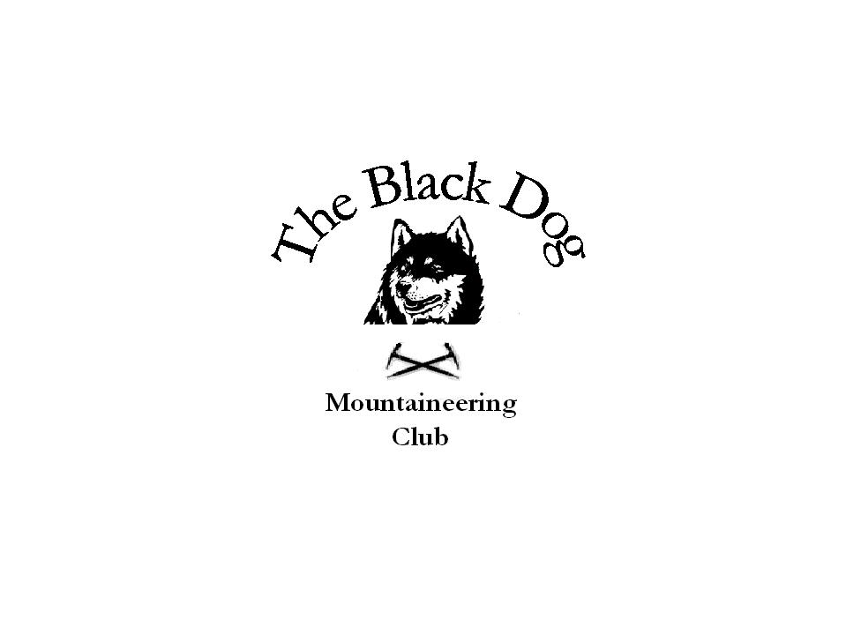Black Dog Meet
No. 95 “Kintail”

Date. Friday 16th to Sunday 18th April 2010

In Attendance. Twenty three people attended at least part of the weekend.

Charles Alexander, Chris Barbour, Dave Barbour, Dave Cameron, Robin Clark, Will Clark, Pat Davis, Steve Davis, Gerry Feeney, Val Inglis, Calum Macdonald, Iain Macdonald, Kirsty McLaren, George Norman, Jon Pickering, Ken Rae, Andy Rob, Michael Ruby, Alan Sewell, Elspeth Shanks, Russell Shanks, Lorna Smith, Tony Smith.

Hills Climbed. Friday
Pat and Steve – Creag Mhor (407m) and Beinn Conchra (643m) Tony, Charles – Beinn a’Chaoinich (410m)
Russell, Elspeth, Chris, Michael, Kirsty, Jon – Sgurr Nan Spainteach (990m), Sgurr Na Ciste Duibhe(1027m), Sgurr Carnach (1002m),
Sgurr Fhuaran (1068m)
Alan, Iain, Calum – Aonach Buidhe (899m), Faochaig (868m)
Gerry, Val, Dave C – Spidean Mialach (996m)
Will and Robin – Sgurr na Sgine (945m)

Saturday
Pat and Steve – Beinn Clachach (643m)
Tony, Lorna, Charles, Robin - Beinn a’Mheadhoin (414m) Alan, Iain, Calum – Sgurr Gaorsaic (839m)
Gerry, Val, Dave C, Kirsty, Jon, George, Andy – Carn Ghluasaid (957m), Sgurr nan Conbhairean (1110m)
Chris, Dave B, Ken – Gleouraich (1035m), Spidean Mialach (996m)

Sunday
Pat and Steve - Beinn a’Mheadhoin (414m)
Tony, Lorna, Charles – Auchtertyre Hill (452m)
George, Michael, Andy, Gerry, Kirsty, Jon – Gairich (919m)
Ken, Dave B – A’Chralaig (1120m)
Russell, Alan, Will, Robin – Climbs on the Poldub Crags – Tear (HS)*, The Gutter (VD)**, Slanting Slab (VD)*, Pine Wall (HS)***

After all those hills (77 in total), my finger is tired so the rest will be brief. Hope they are all correct

Notes. Weather was mixed over the weekend but overall much better than forecast. Some new snow on the tops on Sunday morning but lots of old snow patches and cornices were encountered on the high walks.

Friday
All the Sisters people had a great day in the sun with large areas of snow still present “dodgy cornices” were mentioned. Elspeth and Russell got off to an early start as they had spent the night in their place in Aviemore (which is sometimes available to rent at reasonable prices to people they know) but with only one car were facing a long walk back up the road when a local spotted this young woman in shorts and gave them a lift – lucky them. The rest had arranged cars so came down directly to the hostel.
Those who left Montrose just too late had a huge detour when the local constabulary thought it wise to close a perfectly passable A9 because of an accident. Fortunately they had just planned to do a little hill so still managed to fit it in.
Good to see Iain along with his son Calum at the meet. Calum made Alan feel the same as Alan makes some of us pensioners feel – OLD, well done Calum. They had a great long cycle in on good surface and sunshine but cold on the tops. If you are doing their Friday hills, keep to the Stalker’s path over the col and you will pick up another one to the top of their first hill.

Saturday
Another busy day for most of us. Russell and Elspeth borrowed bikes and went for a run. Michael went for a leisurely walk. Weather was mixed again, some were lucky but others were not – horizontal sleet was encountered by some.
A good day was had by all.
Iain and Calum headed home after their walk with Alan.

Sunday
More people went straight home for various reasons.
The four climbers had a great time – each to their own. This shows the versatility of the club. Ken and Dave B decided against their second target because of cornices but this allowed time for a lazy visit to the Clunie Inn.

A great weekend, god hostel, already booked for next year, good food at the hotel and most importantly GOOD COMPANY.

The next meet on Skye is imminent. Several of the members going on this trip are not going up steep craggy things, so there will be good scope for the more tentative members.

Charles.

Next Meet. Skye (Carbost) Friday 21st to Sunday 23rd May. Steve Smart organising.

