Black Dog Meet Report

No.119 Newtonmore

Saturday 24th March 2012

In Attendance

George Norman Steve Smart
Fiona O’Neill Russell Shanks
Fiona Ruby Lorna Smith
Michael Ruby Tony Smith Alan Sewell

Mountains Climbed

Michael, Fiona R, Tony, Lorna and George Sgairineach Mhor (991m)
Beinn Udlamain (1011m)
A’Mharconaich (975m)
Fiona & Steve S Braeriach (1296m)
Ben Macdui (1309m)
Alan and Russell Climbing (see below)

Weather

Generally a hazy misty start burning off to a glorious sunny day - exactly as forecast by the meet coordinator.

Notes / Highlights

George, Michael, Fiona R, Lorna and Tony
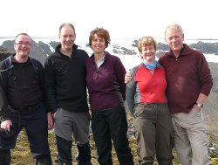

We stopped on a layby on the A9 and walked up the northern bank of the burn in Allt Coire Dhomhain. We crossed a new estate bridge making our way up the slope past the Sow of Atholl to crest the ridge. As we proceeded to Sgairineach Mhor 991m, the sun burnt through the hazy cloud and we started to get some great views. We circled clockwise taking in Beinn Udlamain 1011m, and then along the broad long mossy plateau to A’Mharconaich 975m. Good views of the Ben Alder massive and in the distance Ben Nevis. Some snow remaining in pockets with some good sightings of pairs of ptarmigan shedding their winter plumage. We descended from A’Mharconaich through the only slightly boggy patch of the day.
A great day with stunning views.

Alan and Russell

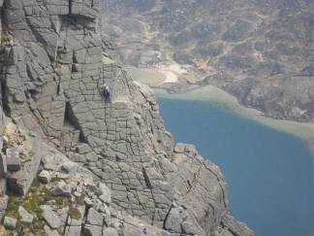

Russell and I were out at the weekend. We stayed in Aviemore on the Friday night and drove up to Applecross on Saturday morning.

We climbed “Sword of Gideon VS 4c*** “ on Sgurr a Chaorachain, where we had the crag to ourselves. This must be the best roadside VS in the country! The weather was brilliant.

In the afternoon we drove around to Ardheslaig (near Shieldaig) and did some routes on a great little crag……

“The Mother in Law, Severe 4a ** “
“Very Gneiss, V Diff ** “
“The Scoop, VS 5a * “
“Scooby Doo, Severe * “

On Sunday we walked into Hells Lum Crag in Loch Avon basin (Cairngorms) but the crag was streaming with water from the snow melting on the corrie lip, so we implemented plan B where we climbed……

“Afterthought arête, Mod *** “ and the “Final Selection Diff *** “ on Stag Rocks - we had over 200m of easy 3 star climbing – just bliss. Again the weather was fantastic.

Fiona O’N and Steve

Starting from the Cairngorm Ski Centre car park we made our way to the Lairig Ghru, then up the Sron na Lairige ridge and on to the summit of Braeriach 1296m. Some gullies still have a lot of snow, you could probably scrape a graded winter ascent. Fantastic summit views, with a rather hazy inversion.
We found an old stalkers path (not on the map) and descended to the Ghru then up to the highly populated Ben Macdui 1309m. We made out way back to the ski centre via the goat track and Coire an t-Sneachda. Lots of reindeer wandering about today. A brilliant walk with superb weather.

Next Meet

Inverie. Friday 20th to Monday 23rd April
Organiser: Steve Davis/Tony Smith

